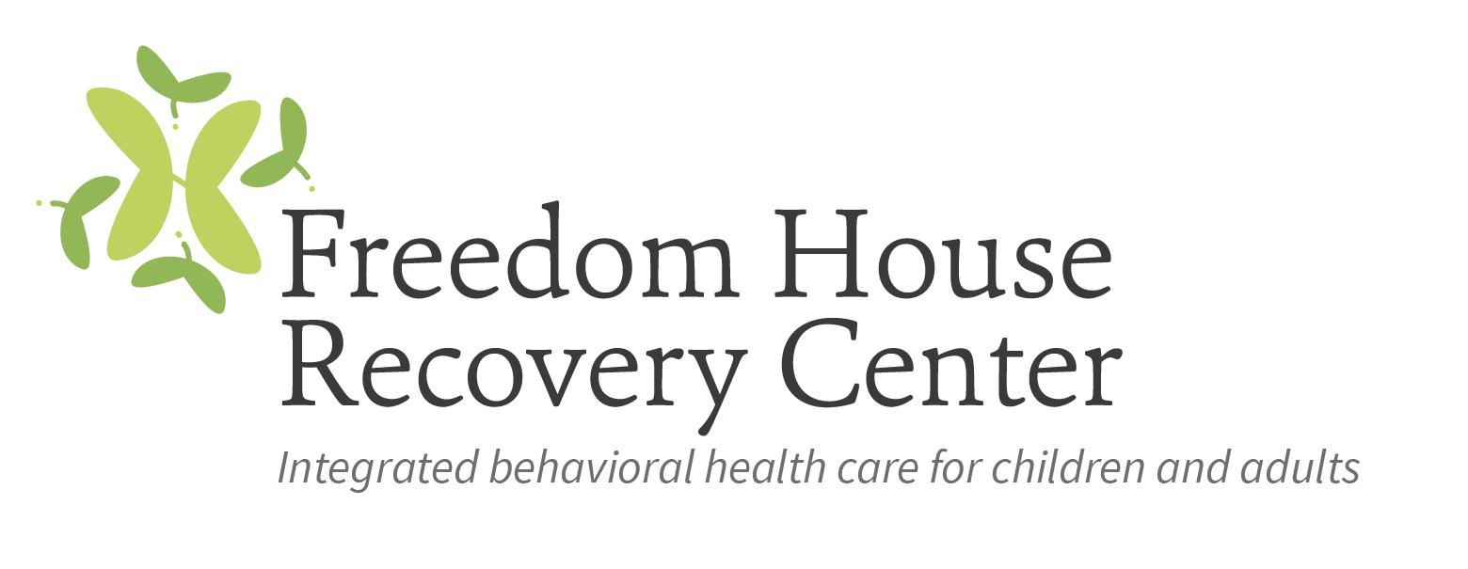

Qualified Mental Health Professional (QMHP)

Freedom House Recovery Center (FHRC) has been operating as a non-profit behavioral health care agency since 1974 and has been providing a broad continuum of person-centered comprehensive services for children, adolescents, adults, and families who suffer from mental health and substance use disorders. FHRC is committed to providing the highest quality care and service to our clients.

FHRC is looking to hire a full-time Qualified Mental Health Professional (QMHP) to conduct Recidivism Reduction Services across several counties. The successful candidate will demonstrate competencies in engaging adjudicated/mandated consumers, conducting group and individual counseling, and providing clear, concise, and timely documentation. The QMHP will be required to develop and maintain positive working relationships with local probation officers in multiple counties. Experience with Moral Reconation Therapy (MRT) preferred.

The ideal candidate for this position will be an outgoing, friendly professional with good clinical boundaries. A Master’s degree in a human service-related field with at least one-year experience in the mental health is preferred. However, a Bachelor’s degree in human services with two-years equivalent work experience will be considered. Salary plus mileage paid for this position.

Interested parties should forward a resume and cover letter to Ivy Williams, HR Director at ivy.w@fhrecovery.org no later than November 30, 2020.

