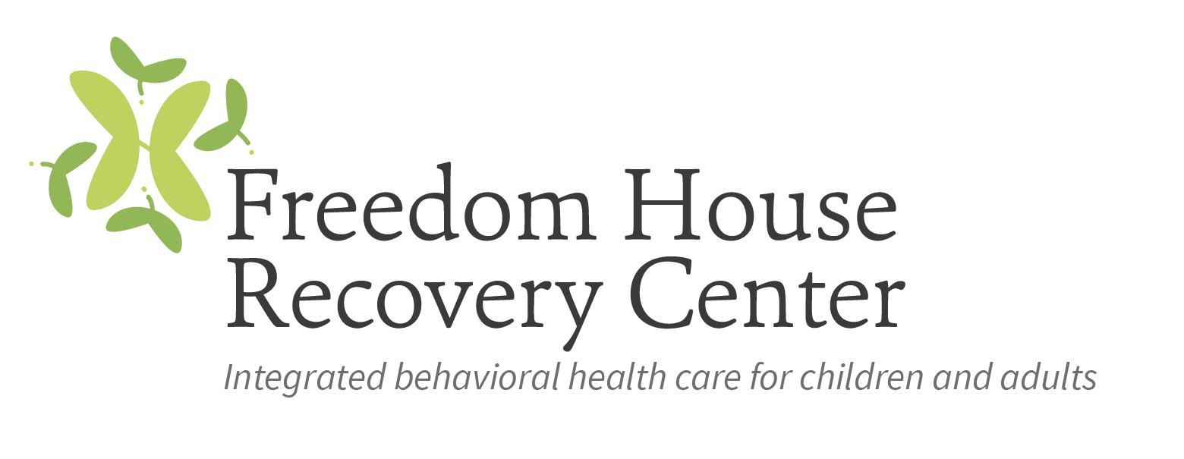

Licensed Clinical Addictions Specialist

Freedom House Recovery Center (FHRC) is a non-profit behavioral health care agency that provides a broad continuum of person-centered, comprehensive services for children, adolescents, adults, and families managing behavioral health disorders or addiction. Freedom House has provided hope and healing to people of all ages, from all walks of life, for over 40 years.

FHRC has an immediate opening for a full-time Licensed Clinical Addictions Specialist who will be responsible for providing individual and group services to children, adolescents, and adults. The LCAS will also conduct SACOT and/or SAIOP groups and assist the clinic with conducting assessments on walk-in clients. Services will be provided at the Person Counseling Center in Roxboro, NC.

A Master’s degree in social work, counseling or a related human services field from an accredited college or university and at least one-year experience in the fields of substance use disorders and mental health is required. A current NC license as a LCAS is preferred, however a provisionally licensed clinician will be considered.

Interested parties should forward a resume to Ivy Williams, Human Resources at ivy.w@fhrecovery.org; if there are questions please call 919-869-4707.

