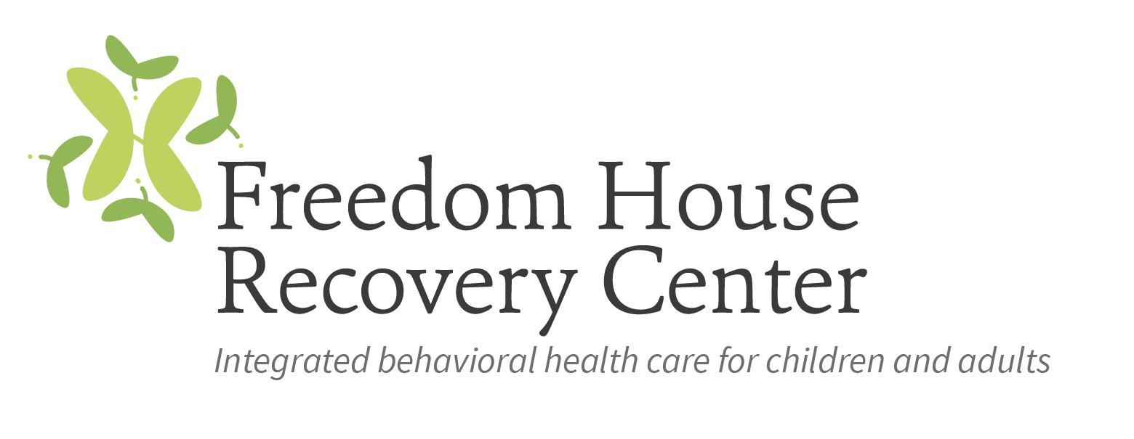

Mental Health Clinician - Telehealth

Freedom House Recovery Center (FHRC) is a non-profit behavioral health care agency that provides a broad continuum of person-centered, comprehensive services for children, adolescents, adults, and families managing behavioral health disorders or addiction. Freedom House has provided hope and healing to people of all ages, from all walks of life, for over 40 years.
FHRC is looking to hire a full-time Licensed Mental Health Clinician who will be responsible for
providing individual and group services to children, adolescents, and adults via telehealth and in our outpatient clinics. The ideal candidate will effectively counsel in individual and groups settings. Must be able to develop and maintain cooperative relationships with clients' families, members of other professional disciplines, social agencies, and co-workers. Must be able to relate professionally with persons with severe and persistent mental illness and/or substance use disorders.

A Master’s degree in social work, counseling, or a related human services field with at least one-year post degree experience in the mental health field is required. Fully licensed clinician preferred, however, will consider a provisionally licensed professional.

Interested parties should forward a resume to Ivy Williams, Human Resources at ivy.w@fhrecovery.org; if there are questions please call 919-869-4707.

