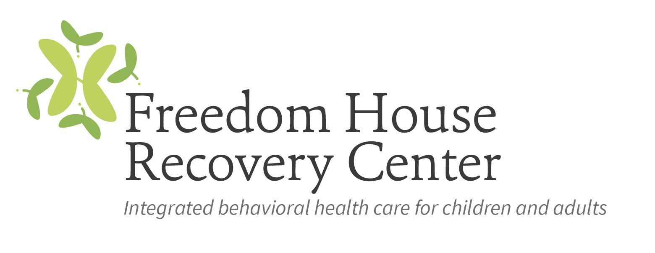

Outpatient Therapist

Freedom House Recovery Center (FHRC) is a non-profit behavioral health care agency that provides a broad continuum of person-centered, comprehensive services for children, adolescents, adults, and families managing behavioral health disorders or addiction. Freedom House has provided hope and healing to people of all ages, from all walks of life, for over 40 years.

Freedom House Recovery Center is seeking to immediately hire two full-time LCSW, LCSWA, LCMHCS, LCMHC, LCHMCA LCAS or LCASA for our Durham Clinic to work with children, adolescents and adults (parents/guardians). Two years of direct clinical experience in MH/SUD’s is required. The candidate must be able to take and successfully complete trainings in de-escalation techniques, CPR and First Aid.
As a licensed clinician, the successful candidate should be enrolled with the Council for Affordable Quality Healthcare (CAQH), NCTRACKS and the appropriate MCO before starting to work at FHRC.
The licensed clinician must: be able to provide both group and individual therapy and assessments (including walk-in) to adults, adolescents and children; have effective time management skills; be able to handle clinical crises and to make quick decisions regarding clinical dispositions; be able to provide crisis intervention when necessary; have knowledge of community resources and advocacy services; have knowledge of the socio-cultural characteristics of the population being served; have the ability to understand and apply relevant laws, regulations, rules, standards, policies and procedures; and, possess good interpersonal, oral and written communication and computer skills.

