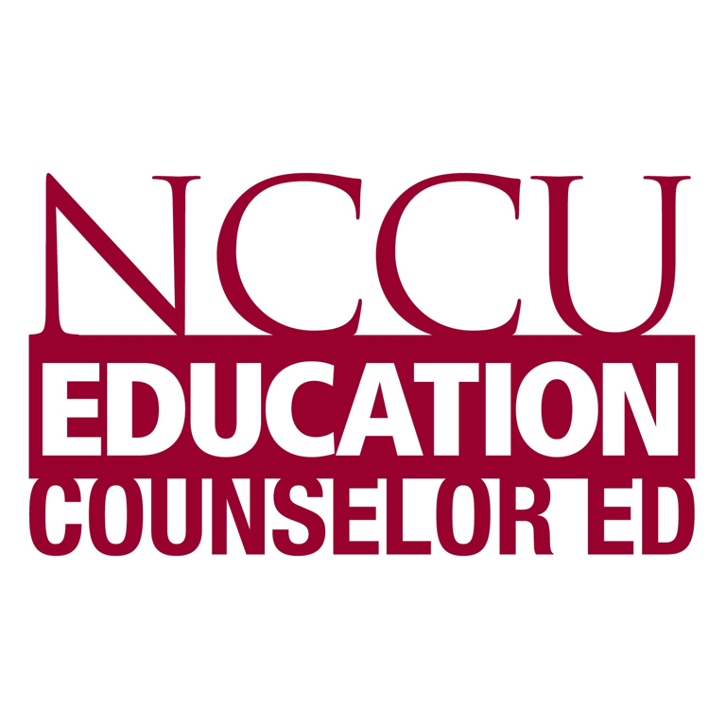
North Carolina Central University
“Communicating to Succeed”

The School of Education’s Vision: To become an international community of scholars who are culturally responsive educators and practitioners
MISSION

The mission of North Carolina Central University is to prepare students academically and professionally to become leaders to advance consciousness of social responsibility in a diverse, global society. In accordance with the larger institution, the mission of the North Carolina Central School of Education is “to prepare educational professionals to serve and inspire excellence in teaching, administration, counseling, communication, technology, community outreach, and other related services”. Central to this aim is “the development of leaders who promote social justice and dedicate themselves to the well-being of a global society”. The Counselor Education Program prepares counselors to work in mental health, school, and career counseling settings who promote social justice and responsibility, serve as leaders in a diverse and global community, and respond to the complexity of human needs across the lifespan. To this end, the program emphasizes increasing awareness, knowledge, and skills in interacting with economically, socially, and culturally diverse populations. Our partnerships with local agencies and schools foster an understanding of multicultural and diverse populations and counseling interventions that promote empowerment.

http://www.nccucounseling.com

CON 5325
Advanced Career Counseling

Summer Session 2 - 2016

Instructor: Suzan Wasik, PhD, LPCS
Office: 2132 School of Education
Campus Phone: 919.530.5179
Email: swasik@nccu.edu
Office Hours: No regular office hours during the summer – Please email as needed. I respond within 24-36 hours Monday-Friday 9-5pm EST (excluding holidays).

Foliotek Statement:

Maintaining an electronic portfolio (i.e., 'Foliotek') is a REQUIREMENT for continued enrollment as a degree-seeking student in the School of Education at North Carolina Central University. You MUST maintain a Foliotek account while enrolled in school, and you will be required to upload a majority of your assignments to the system. The university will use the information to track data and verify that you have met competencies of your program of study - but more importantly - this system will serve as your own professional e-portfolio and file storage. Some of the course assignments will be submitted using the test functions available in Blackboard. If this is the case, it is recommended that you either print a copy of the submission so that you can upload it to Foliotek - or maintain a digital version within something like word procession software on your own computer (copy and paste into your software).

Required Texts:

Zunker, V. (2011). Career counseling: A holistic approach (9th ed.). Pacific Grove, CA: Brooks/Cole.

Osborn, D., & Zunker, G. (2011). Using Assessment Results for Career Development (8th ed.). Brooks/Cole.

Bolles, R. N. (2016). What color is your parachute? (2016 ed.). Berkeley, CA: Ten Speed Press.

Older editions of the Bolles text are acceptable (this text is updated every year).

It is possible that there are newer (and older) editions of the other two books available. You may certainly purchase different editions of the texts. However, please keep in mind that sometimes the author(s) may change the order of chapters between editions. The chapter number assigned may be different than what is printed in a different edition. It will be your responsibility to make sure that you are reading the appropriate/assigned content, regardless of the chapter number.
Course Description:

Prerequisites: CON 5320. This course will provide specialized instruction for candidates in the
Career Counseling concentration of the Counselor Education Program. Candidates will be
provided instruction in the foundations of career counseling and the contextual dimensions of
career counseling. Knowledge and skill requirements for career counselors will be emphasized,
covering the application of career information systems, research and evaluation in career
counseling, and ethical and legal issues specific to career counselors.

Learning Outcomes

Department of Counselor Education Program Outcomes  The program develops counselors who can demonstrate: | Course(s) Covered*
- A theoretically based philosophy of practice and professional identity that responds to the needs of their clients; | CON 5200; Career: CON 5320; CON 5325; Community Agency: CON 5380; School: CON 5303
- Expertise in individual, group and family work with culturally diverse clients on educational, career, social, emotional, or personal issues that impact client development in various settings across their lifespan; | Individual: CON 5371; Group: CON 5351; Family: CON 5372; Diversity: CON 5360; Development: CON 5331
- Leadership ability and advocacy skills to meet client needs and remove individual and environmental barriers to development; | CON 5360; Career: CON 5320; Community Agency: CON 5380; School: CON 5303
- The ability to build collaborative partnerships with stakeholders for promoting access, equity, and social justice; | CON 5360; CON 5373
- The ability to utilize appropriate assessment tools and procedures; | CON 5361
- The ability to consult with other professionals and administrators concerning the developmental needs of culturally diverse clients; | CON 5373; CON 5360; CON 5390
- The ability to conduct and utilize research to enhance client development; | EDGR 5910; EDGR 5920; CON 5390
- Knowledge, skills, and dispositions in the application of the ACA code of ethics. | CON 5371; CON 5390

CON 5325 - Student Learning Outcomes  When applicable, corresponding CACREP Standards (2008-2009 Standards) are listed with each objective.  The student will be able to… | METHOD FOR OBTAINING  OUTCOME | METHOD FOR EVALUATION OF OUTCOME
- Demonstrate ability to apply knowledge of program planning, needs assessment, and program evaluation to effect program modification (II, K, 8, d – old standards) | Reading, Field Experience | Field Experience Report
- Demonstrate understanding of ethical and legal considerations specifically related to the practice of career counseling. (Standards for Career Counseling Programs - A.2.) | Reading, Field Experience | Field Experience Report
- Demonstrate knowledge of the roles, functions and settings of career counselors, including private and public sector agencies and institutions. (Standards for Career Counseling Programs - A.3.). | Reading, Field Experience | Field Experience Report
- Demonstrate understanding of policies, laws, and regulations relevant to career counseling and career development programs (e.g., ADA). (Standards for Career Counseling Programs - A.6.) | Reading, Field Experience | Field Experience Report
- Demonstrate understanding of techniques of career development, career counseling, career choice, career programming, and associated information delivery. (Standards for Career Counseling Programs – C.1.) | Reading | Final Summative paper, Quizzes
- Demonstrate understanding of the impact of crises, emergencies and disasters on individuals’ career planning and development (Standards for Career Counseling Programs – C.3.) | Reading | Final Summative paper, Quizzes
- Demonstrate understanding of the role of multicultural issues in career counseling (Standards for Career Counseling Programs – E.1.) | Reading | Final Summative paper, Quizzes
- Demonstrate understanding of the role of racism, discrimination, power, privilege, and oppression in one’s own life and career and those of the client (Standards for Career Counseling Programs – E.2.) | Reading | Final Summative paper, Quizzes
- Demonstrate understanding of the sociopolitical and socioeconomic forces that impact the career opportunities of ethnic and cultural minorities, such as immigration, racism, and stereotyping (Standards for Career Counseling Programs – E.3.) | Reading | Final Summative paper, Quizzes
- Demonstrate understanding of the changing roles of women and men and the implications that this change has on employment, education, family, and leisure (Standards for Career Counseling Programs – E.4.) | Reading | Final Summative paper, Quizzes
- Demonstrate understanding of assessment strategies for career development and career counseling programs (Standards for Career Counseling Programs – G.1.) | Reading | Final Summative paper, Quizzes
- Demonstrate understanding of how to choose the appropriate career assessment tools and techniques (Standards for Career Counseling Programs – G.2.) | Reading | Final Summative paper, Quizzes
- Demonstrate understanding of bias in career assessment and interpretation (including cultural and linguistic characteristics of the client.) (Standards for Career Counseling Programs – G.3.) | Reading | Final Summative paper, Quizzes
- Demonstrates an ability to administer, score, and appropriately report findings from career assessment instruments involving issues such as leisure interests, learning style, life roles, self-concept, career maturity, vocational identity, career indecision, work environment preference (e.g., work satisfaction), and other related life style/development issues (Standards for Career Counseling Programs – H.1.) | Reading | Final Summative paper, Quizzes
- Demonstrates an ability to assess conditions of the work environment (e.g. tasks, expectations, norms, and qualities of the physical and social settings) (Standards for Career Counseling Programs – H.3.) | Reading, Field Experience | Field Experience Report
- Identify models of program evaluation for career counseling and development programs (Standards for Career Counseling Programs – I.2.) | Reading, Field Experience | Field Experience Report
- Demonstrate understanding of basic strategies for evaluating counseling outcomes in career counseling (Standards for Career Counseling Programs – I.3.) | Reading, Field Experience | Field Experience Report
- Applies relevant research findings to inform the practice of career counseling (Standards for Career Counseling Programs – J.1.) | Project research | Project
- Demonstrate understanding of the resources applicable in job forecasting, planning, policy analysis, and resource allocation (Standards for Career Counseling Programs – K.2.) | Reading | Final Summative paper, Quizzes
- Demonstrate understanding of the resources and skills that clients use in life-work planning and management (Standards for Career Counseling Programs – M.2.) | Reading | Final Summative paper, Quizzes
- Demonstrate understanding of the community/professional resources available to assist clients in career planning, including job search (Standards for Career Counseling Programs – M.3.) | Reading, Field Experience, Project research | Project  Field Experience Report

COURSE POLICIES AND EXPECTATIONS

- Read the entire syllabus. Follow all directions and due dates provided in the syllabus and on the website (no exceptions).
- All work submitted should reflect graduate level content and preparation. Careless preparation (i.e., spelling and grammatical errors) or inappropriate presentations will negatively affect the grade for that assignment or task. Do not submit any work that you have not proofread. Late assignments, if accepted, will have a reduced grade.
- Please complete all of your coursework independently, unless the assignment specifically requires collaboration with classmates. All of your coursework should be attempted on your own. Plagiarizing work in any assignment will result in automatic failure in the course.
- Be sure to have your class and NCCU accounts paid for and up to date. The registrar’s office WILL drop students for unpaid fees. This is especially problematic for summer courses because students will automatically lose their online access to this course. Because summer classes move so quickly, missing even a day or two of classes will cause you to fall very far behind very quickly. If you are dropped from this class, you will not be allowed to make-up any missed work due to the nature and speed of this summer course. Please be aware of any and all outstanding NCCU fees prior to class beginning!
- Read and listen/watch all material provided on the course website as it is presented (e.g., Mindtap, videos, podcasts, supplemental readings, etc.). Complete all assigned readings. It is not acceptable to read only a portion of the reading assignments for this course. You are expected to be prepared to discuss, summarize, and react to all readings.
- Mindtap is a rich resource that helps bring the textbook and online learning to life. There are several videos, case studies, readings and short quizzes that are included in Mindtap. Although not graded, these have been assigned to help you better understand the material. The expectations are that you will be viewing them and taking the online quizzes as assigned.
- Regularly check your NCCU email account. I will correspond with you from time to time via campus email. If you are not receiving communication because you aren’t checking the account regularly, then it is not the fault of the instructor.
- Ensure that you are entirely familiar with all functions available to you via Blackboard. Not knowing how to use various functions of Blackboard is not an excuse for not completing assignments. Contact the campus ITS helpline should you experience technical problems related to Blackboard (919/530-7676).
- Do not email your work to the instructor unless specifically asked to do so by the instructor. For most assignments, if not all of them, you will use designated links within Blackboard to submit your work. Please use the Blackboard system to submit your work; email submissions will not be accepted.
- You are given a "window" of time to complete assignments, and you do not have to wait until the last minute to complete your work. The Blackboard system moves slowly and encounters problems from time to time. Please avoid doing things at the last minute. It is very unlikely that you will be given any extra time to complete an assignment if you waited until the last minute to complete a task - and then experienced a technical issue. Work on things early so that you can overcome the technical problems, should they arise.
- Adverse Weather: The University makes all decisions regarding the cancellation of classes. Because this is an online class, the cancellation of university classes should not affect your coursework or assignments.

COURSE REQUIREMENTS AND ASSIGNMENTS
Please complete all tasks posted weekly under “Course Content”.

- Readings and Short Answer Essays:

There will be short answer/essay questions that you will need to respond to every week. If you fail to complete and click “submit” for an assignment, you will be given a zero for that assignment. The instructor is unable to read anything that you have “saved” in order to come back to later. You must click “submit”. Responses will be subjectively graded based on your comprehension of the question and your ability to knowledgeably respond to it. There will be no length requirement for your responses. Keep in mind that you want to give enough of a response for your instructor to be able to evaluate your comprehension and knowledge (i.e., the more detailed and knowledgeable your response, the better your grade). Your responses should be very specific - do not provide broad or generic responses.

Every assignment must be completed by 11:59pm on the day it is due. Once the due date passes for one assignment, the next assignment will be available.

Distance education classes require a fair amount of self-discipline. It will be your responsibility to remember to complete your assignments. Once the due date ends and the link disappears, it will not be made available again. Unfortunately, if you forget to complete an assignment you will be given a zero.

2. Field Experience Report: (Note: *This is a Foliotek Assignment for Career Majors)

You are required to visit three different career development/career counseling sites:

1. A university or community college Career Services Center (other than NC Central University’s Career Center).

2. A private for-profit agency that provides career counseling services (i.e. employment agency or private practice that provides career counseling as well).

3. A non-profit agency that provides career counseling services (i.e., Women’s Center, employment security commission, Work First, etc..).

The Field Experience is an important component of the course requirements; it will be in your best interest to invest some time in ensuring that your visits will be “quality” visits.

You will be responsible for researching, locating, and scheduling your visits. (In other words, don’t wait until the last minute to start your field experience visits). Please identify who you are and the nature of the assignment. Ask permission before going - and request if someone (a career counselor) at each site could give you a tour of their facility and be available to answer a few questions.

You will be required to submit a two-part report of your field experience. The first part will be a report of your visits; the second part will require you to apply needs assessment/program evaluation concepts to one of the locations. Your report will be submitted using the link posted under Assignments.

In the first part, you will want to answer the following questions for each site visited:

- Describe the site (layout, nature of clients served, specific programs).

- What are the roles, functions, and credentials of the career counselors at the site?

- What types of policies, laws, or regulations do they follow with respect to career
counseling at their site?

(d) In your opinion, how well does the site attempt to address the continuum of formal and informal career counseling? How so?

(e) What types of training do the career counselors at the site conduct with their clients (e.g., training others about the use and application of career development programs, computer-based systems, other career-information systems).

In the second part, select one of the three sites you visited. Pick one program that they have implemented at their site and pretend that you have been asked to conduct a needs assessment and program evaluation of the program. Respond to the following items in the second part of your report:

(a) Describe what you would do to conduct a needs assessment and program evaluation. Please be specific.

(b) Describe the results that you might find based on your needs assessment/evaluation (Hypothesize what results you might find).

(c) Based on your hypothesized results, how might they effect program modifications for the site?

Your Field Experience Report is due by 11:59pm on the date listed in the course schedule. It will be worth 150 points. Again, this assignment will be submitted using the link found on Blackboard.

- Project: (Note: *This is a Foliotek Assignment for Career Majors)

There are three groups of documents that you will need to submit for the completion of the project (Resume Review, Job Search Tips Handout, Job Interview Tips Handout). All of these documents will be submitted using the links for the assignments found on the Blackboard course site.

  - Resume Review

Please do not rely on what you think you know about resumes to complete this part of the project, if you did not take CON 5320 at NCCU. This assignment is intended to build upon the work that you did for the resume review assignment in CON 5320. You will need to review the recording by Dr. Royal posted on Blackboard on resume writing, if you have not viewed it before (available on the course website). If it has been longer than a semester or two since you viewed it previously, I would encourage you to view it again.

The resumes that you submit should be pristine in their appearance (i.e., absolutely no errors). Solicit the help of five (5) acquaintances.

    - Obtain digital copies of these five (5) individuals’ resumes.

    - Review, edit, and revise their resumes (digitally, using word processing software).

    - Submit digital copies of the original versions of their resumes – as well as copies of your newly edited versions of their resumes (submitted via digital drop box). The original version should contain the word “original” at the end of the file name. The edited versions should contain the word “edited” at the end of the file name. For example, if you were reviewing my resume (as one of your five), you would submit two files with my name on it. One would be titled “Suzan_Wasik_Original”....the other would be titled “Suzan_Wasik_Edited.” It is encouraged that you submit your work within a zipped (or compressed) folder, so that you only have to attach one document.

This part of the project is worth 50 points.

  - Job Search Tips Handout

You will need to create and submit a handout (or brochure) that you would provide to a future client regarding “how to conduct a job search.” It is expected that you conduct some research to determine the current “best practices” for a job search. Essentially, your handout will contain helpful tips and strategies for a job seeker. Please do not tailor your handout/brochure to one specific field; rather, make it applicable for any or all fields. The handout that you submit should be pristine in its appearance (i.e., absolutely no errors). Submit your job search handout in an image (e.g., .jpg, .png) or .pdf format by 11:59pm on the date listed in the course schedule.
This part of the project is worth 25 points.

  - Job Interview Tips Handout

You will need to create and submit a handout (or brochure) that you would provide to a future client regarding “how to approach and survive a job interview.”. Like your products, it is expected that you conduct some research to determine the current “best practices” for approaching an interview and answering questions. Essentially, your handout will contain helpful tips and strategies for an interviewee. Please do not tailor your handout/brochure to one specific field; rather, make it applicable for any or all fields. The handout that you submit should be pristine in its appearance (i.e., absolutely no errors). Submit your interviewing handout in an image or pdf format by 11:59pm on the date listed in the course schedule. This part of the project is worth 25 points.

- FINAL SUMMATIVE PAPER: (Note: *This is a Foliotek Assignment for Career Majors)
The final course task is to respond to prompts regarding the course objectives, but it is recommended that you begin this assignment early in the session. You will find these prompts under Assignments in Blackboard. Each element/question will require at most around a one to three paragraph response. It is entirely possible that all areas on the summative paper will not have been directly covered during the course - and you will be expected to research the topic to an extent.
It would be wise to address this assignment on a weekly basis and answer the questions as you go along. Use a word document to create your answers and cut and paste those answers onto the Blackboard site. You can save your answers and go back to it. However, once you hit submit, it will be submitted for a grade.
Save this assignment in a word document format so that you can upload it onto Foliotek as well!
The final paper is worth 100 points.

Grading
Weekly short answer questions 120 points
Field Experience Report * 150 points
Project* 100 points
Final Summative Paper* 100 points
TOTAL 470 points

(*Foliotek assignments to be uploaded for Career Counseling Majors.)

Grading Scale
423-470 = A
376-422 = B
329-375 = C
<329 = F
Course Schedule and Readings: (Subject to Change by Instructor)

Date | Topic |  | Readings Due |  | Due  By 11:59pm
WEEK 1  July 5 – July 11 | Historical Development and Some Basic Issues  Integrating Career and Personal Counseling  Career Counseling Intake Interview  Some Career Information Resources and Learning Platforms  On Being an Ethical Career Counselor | Z - Ch 1  Z - Ch 4  Z - Ch 5  Z - Ch 7  Z - Ch 8  Bolles - Ch 1-4, & 14 |  | Short Answer 1 -  Due by July 12
WEEK 2  July 12- July 18 | Gender Issues and Dual Careers  Job Loss and Transitions  Career-Related Pgms for CD in Elementary School  Career-Related Pgms for CD is Middle School  Career-Related Pgms for CD in High School and Beyond | Z - Ch 10  Z - Ch 13  Z - Ch 15  Z - Ch 16  Z - Ch 17  Bolles - Ch 5-6 |  | Short Answer 2 –  Due July 19  Job Search Tips Handout Due  July 19
WEEK 3  July 19- July 25 | A Conceptual Model for Using Assessment Results  Interpreting Assessment Results  Aptitude and Achievement Tests  Interest Inventories  Personality Inventories | O & Z - Ch 1  O & Z - Ch 2  O & Z - Ch 5  O & Z - Ch 6  O & Z - Ch 7  Bolles - Ch 7-9 |  | Short Answer 3 –  Due July 26  Job Interview Tips Handout Due  July 26
WEEK 4  July 26-  August 3 | Career Decision Inventories  Computer-assisted Career Guidance and Online Career Assessments  Card Sorts and Other Non-Standardized Assessments  Combining Assessment Results | O & Z - Ch 8  O & Z - Ch 9  O & Z - Ch 10  O & Z - Ch 11  Bolles - Ch 13, Bolles – Appendices A, B, C, & D |  | Field Experience Report due Aug 1  Short Answer 4 –  Due August 2  Resume Reviews- Due August 2
Aug 1 | Field Experience Report Due |  |  |  | Field Experience Report due Aug 1
Aug 3 | Final Summative Paper Due  Last Day of Classes |  |  |  | Final Summative Paper due August 3

My Advice to You:

The pace of this class is FAST! Tips for success…

1. Make appointments to visit career sites today! Have the visits COMPLETED by July 22.
2. Ask 10 friends to send you their resumes TODAY. You will need to review at least 5.
3. Work on Short Answer Assignments and Final Summative Paper every day as you are reading.
4. Keep up with reading. Read every single day. Stay ahead of the game. Do not get behind.
5. Keep in touch. Reach out if you have any questions. Email is the best and quickest way.
6. Remember that the last week of class (July 25-August 3) has many deadlines. Keep them strait.
7. You can do this! You can succeed! It is only 30 days!

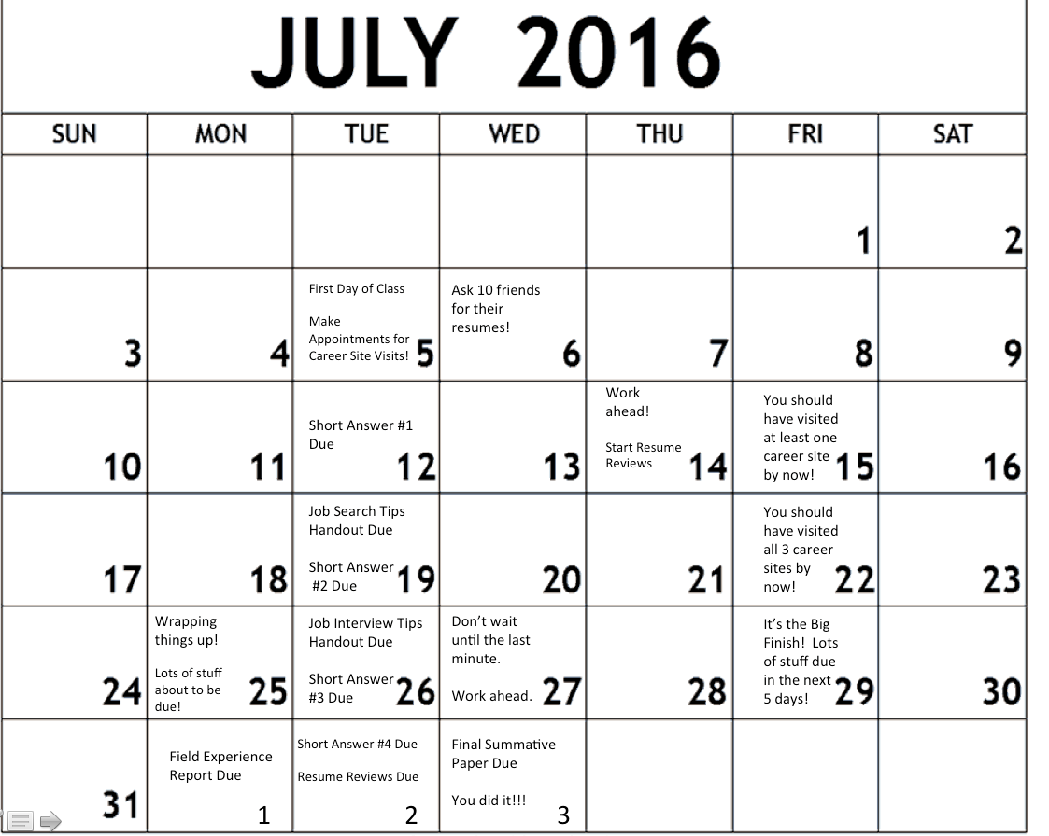

Additional Resources

Bachay, J. B., & Rigby, E. T. (1997). Welcome to our school community: A career development intervention for the newcomer. Professional School Counseling, 1, 13-14.
Brown, D., & Brooks, L. (Eds.). (1996). Career choice and development (3rd Ed.). San Francisco: Josey Bass.
Burlew, L. D., & Morrison, J. (1996). Enhancing the effectiveness of vocational assessment in promoting lifestyle change via specific change strategies. Measurement and Evaluation in Counseling and Development, 29, 163-175.
Chen, C. (2003). Integrating perspectives in career development theory and practice. Career Development Quarterly, 51, 203-216.
Chung, Y. B. (2001). Work discrimination and coping strategies: Conceptual frameworks for counseling lesbian, gay, and bisexual clients. Career Development Quarterly, 50, 33-44.
Chung, Y. B. (2003). Career counseling with lesbian, gay, bisexual, and transgendered persons: The next decade, Career Development Quarterly, 52, 78-86.
Day, S. X., & Rounds, J. (1998). Universality of vocational interest structure among racial and ethnic minorities. American Psychologist, 53, 728-736.
Gati, I., & Asher, I. (2001). Prescreening, in-depth exploration, and choice: From decision theory to career counseling practice. Career Development Quarterly, 50, 140-157.
Gibson, D.M. (2005). The use of genograms in career counseling with elementary, middle, and high school students. Career Development Quarterly, 53, 353-362.
Guindon, M., & Hanna, F. (2002). Coincidence, happenstance, serendipity, fate, or the hand of God: Case studies in synchronicity. Career Development Quarterly, 50, 195-208.
Grimm, J. H. (1997). The college application process: Preparing high school juniors for senior panic. The School Counselor, 44, 312-314.
Gysbers, N. C., & Henderson, P. (1994). Developing and managing your school guidance program (2nd ed.). Washington, DC: American Counseling Association.
Harris-Bowlsbey, J. (2003). A rich past and a future vision. Career Development Quarterly, 52, 18-25.
Harris-Bowlsbey, J., & Sampson, J. (2001). Computer-based career planning systems: Dreams and realities. Career Development Quarterly, 49, 250-260.
Healy, C. C., & Woodward, G. A. (1998). The Myers-Briggs Type Indicator and career obstacles. Measurement and Evaluation in Counseling and Development, 31, 74-85.
Herr, E. L., & Cramer, S. H. (1992). Career guidance and counseling through the life-span. New York: Harper Collins.
Hershenson, D. B. (1996). Work adjustment: A neglected area in career counseling. Journal of Counseling and Development, 74, 442-446.
Hogan, R., Hogan, J., & Roberts, B. W. (1996). Personality measurement and employment decisions. Questions and answers. American Psychologist, 51, 469-477.
Jones, L. K. (1996). A harsh and challenging world of work: Implications for counselors. Journal of Counseling and Development, 74, 453-459.
Lapan, R. T., Gysbers, N. C., & Sun, Y. (1997). The impact of more fully implemented guidance programs on the school experiences of high school students: A statewide evaluation study. Journal of Counseling and Development, 75, 292-302.
Malott, K., & Magnuson, S. (2004). Using genograms to facilitate undergraduate students’ career development: A group model. Career Development Quarterly, 53, 178-186.
McMahon, M., Patton, W., & Watson, M. (2003). Developing qualitative career assessment processes. Career Development Quarterly, 51, 194-202.
Michelozzi, B. N. (1992). Coming alive from nine to five (4th ed.). London: Mayfield.
Miner, C. U., Osborne, W. L., & Jaeger, R. M. (1997). The ability of career maturity indicators to predict interest score differentiation, consistency, and elevation. Measurement and Evaluation in Counseling and Development, 29, 187-201.
Osborn, D., Peterson, G., Sampson, J., & Reardon, R. (2003). Client anticipations about computer-assisted career guidance system outcomes. Career Development Quarterly, 51, 356-367.
Osipow, S. H., & Fitzgerald, L. F. (1996). Theories of career development (4th ed.). Boston: Allyn and Bacon.
Peterson, N., Cortez Gonzalez, R. (2005). The role of work in people’s lives: Applied career counseling and vocational psychology (2nd ed.). Pacific Grove, CA: Brooks/Cole.
Pope, M. (2000). A brief history of career counseling in the United States. Career Development Quarterly, 48, 194-211.
Pope, M., Barret, B., Szymanski, D., Chung, Y., Singaravelu, H., McLean, R., & Sanabria, S. (2004). Culturally appropriate Career Counseling with gay and lesbian clients, Career Development Quarterly, 53, 157-176.Prediger, D. J. (1998). Is interest profile level relevant to career counseling? Journal of Counseling Psychology, 45, 204-211.
Prediger, D. J. (1998). Is interest profile level relevant to career counseling? Journal of Counseling Psychology, 45, 204-211.
Reardon, R. (1996). A program an cost analysis of a self-directed career decision making program in a university career center. Journal of Counseling and Development, 74, 280-285.
Royal, C. (2007, April). Podcasting in career development. Career Convergence. Retrieved April 1, 2007 from http://www.ncda.org/
Sharf. R. (1993). Occupational information overview. Pacific Grove, CA: Brooks/Cole.
Sharf, R. (2005). Applying Career Development Theory to Counseling (4th ed.). Pacific Grove, CA: Brooks/Cole.
Tang, M. (2003). Career counseling in the future: Constructing, collaborating, advocating. Career Development Quarterly, 52, 61-69.
Tinsley, H. (2000). Technological magic, social change and counseling rituals: The future of career assessment. Journal of Career Assessment, 8, 339-350.
Tracey, T. J. G., & Ward, J. C. (1998). The structure of children's interests and competence perceptions. Journal of Counseling Psychology, 45, 290-303.
Wilkes-Hull, M., Crosswait, B. (1996). Professional development: the dynamics of success (5th ed.). Pacific Grove, CA: Brooks/Cole.
Yost, E. B., & Corbishley, M. A. (1987). Career counseling: A psychological approach. San Francisco: Josey-Bass.
Zunker, V.G. (2008). Career, Work, and Mental Health: Integrating Career and Personal Counseling. Thousand Oaks, CA: SAGE.

Student Support Services for Students with Disabilities

Students with disabilities (physical, learning, psychological, chronic medical, etc.) who would like to request accommodations and services are required to register with the Office of Student Disability Services in Suite G20 in the Student Services Building. Please contact Kesha Lee, Director at (919) 530-6325 or email studentdisabilityservices@nccu.edu. If you are already registered in the office, you will need to return to the office each semester to review your information and receive updated accommodations.

VETERANS SERVICES

One of the goals of the faculty and the NCCU Veterans Affairs Office’s (VAO) is to provide a welcoming and supportive learning experience for veterans. Specifically, the VAO’s primary goal is to provide a smooth transition from military to college life for veterans, service members, and dependents. If you wish, please contact your professor and/or the Director of the VAO during the first weeks of class so that we may support and assist you. During your matriculation, the VAO is here to assist you with the VA Educational Benefits process and offer overall support to ensure academic progression towards graduation. For more information please contact the VAO at 919-530-5000 or veteransaffairs@nccu.edu.

