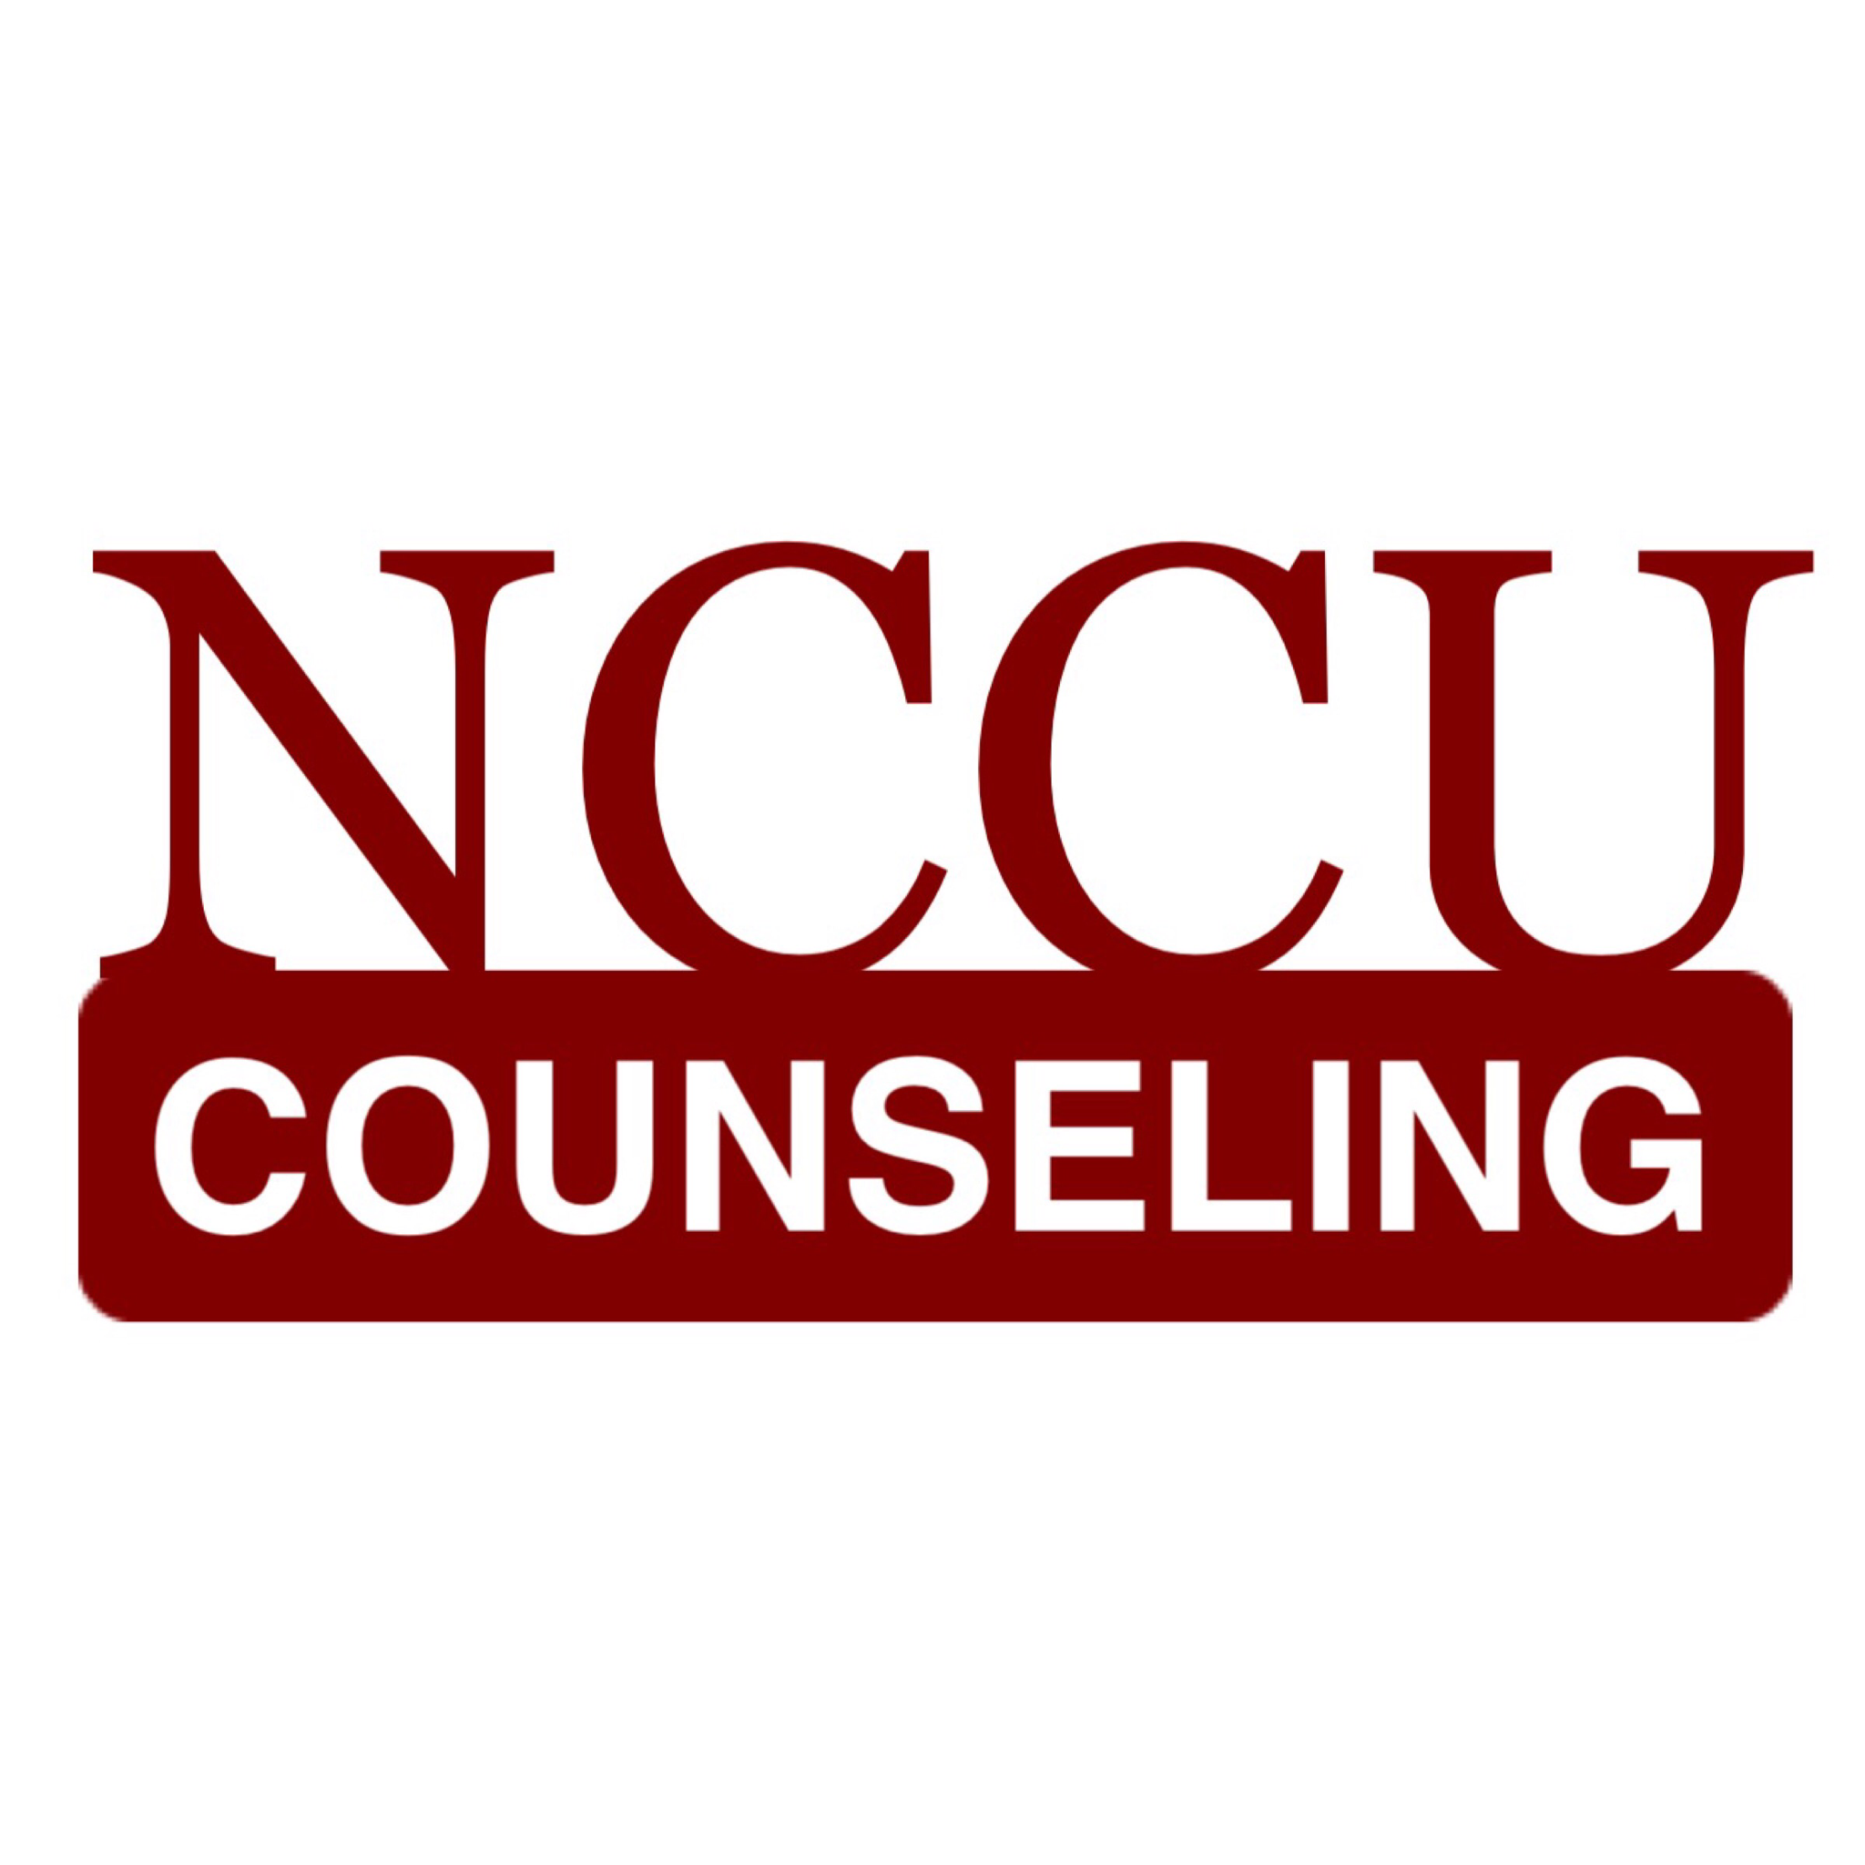

North Carolina Central University
“Communicating to Succeed”
“Preparing Educators for Diverse Cultural Contexts for the 21st Century”

The School of Education’s Vision: To become an international community of scholars who are culturally responsive educators and practitioners
MISSION

The mission of North Carolina Central University is to prepare students academically and professionally to become leaders to advance consciousness of social responsibility in a diverse, global society. In accordance with the larger institution, the mission of the North Carolina Central School of Education is “to prepare educational professionals to serve and inspire excellence in teaching, administration, counseling, communication, technology, community outreach, and other related services”. Central to this aim is “the development of leaders who promote social justice and dedicate themselves to the well-being of a global society”. The Counselor Education Program prepares counselors to work in mental health, school, and career counseling settings who promote social justice and responsibility, serve as leaders in a diverse and global community, and respond to the complexity of human needs across the lifespan. To this end, the program emphasizes increasing awareness, knowledge, and skills in interacting with economically, socially, and culturally diverse populations. Our partnerships with local agencies and schools foster an understanding of multicultural and diverse populations and counseling interventions that promote empowerment.

www.nccucounseling.com

Syllabus

CON 5331
Psychosocial Development and Behavioral Dynamics

FALL 2016

Instructor: Chadwick Royal, Ph.D., LPCS
Office: 2127 H.M. Michaux School of Education Building
Telephone: 919-530-6465
Skype username: chadwick.royal
email: croyal@nccu.edu
Office Hours (campus): Tues. 9:30am-3pm
Office Hours (virtual): Mon., Wed., & Thurs. 10-11:30am

On Mondays, Wednesdays, and Thursdays, you may (a) call my office # or (b) Skype with me (video and/or audio). On Tuesdays, you are welcome to call or stop by the office.

If you would like to schedule an appointment for time during office hours, please visit: http://croyal.appointy.com/

Required texts:

1. Newman, B. M., & Newman, P. R. (2015). Development through life: A psychosocial approach (12th ed.). Belmont, CA: Thomson/Wadsworth.
2. Crain, W. (2011). Theories of Development (6th ed.). Prentice Hall.

Course Description:

A focus on the developmental process and the behavioral dynamics of individuals over the life span. Theories of personality and their relevance for client understanding will be explored.

Foliotek Statement:

Maintaining an electronic portfolio (i.e., 'Foliotek') is a REQUIREMENT for continued enrollment as a degree-seeking student in the School of Education at North Carolina Central University. You MUST maintain a Foliotek account while enrolled in school, and you will be required to upload a majority of your assignments to the system. The university will use the information to track data and verify that you have met competencies of your program of study - but more importantly - this system will serve as your own professional e-portfolio and file storage. There will be multiple assignments from this class that you will need to upload to Foliotek once the course ends.

EXPECTED Learning Outcomes

COUNSELOR EDUCATION PROGRAM OBJECTIVES

The program develops counselors who:
- Develop a theoretically solid philosophy of practice;
- Apply knowledge, skills, and dispositions consistent with the ACA Code of Ethics;
- Formulate a professional identity that responds to the needs of their client populations;
- Utilize cultural competence in practice;
- Act with expertise in individual, group, and family counseling with diverse clients on personal, social, emotional, career, and educational issues that impact development across their lifespan;
- Develop leadership ability and advocate to meet client needs and to remove individual and systemic barriers to development;
- Build and sustain collaborative partnerships with stakeholders for promoting social justice, equity, and access;
- Utilize appropriate assessment tools and procedures;
- Consult with others concerning the developmental needs of culturally diverse clients;
- Integrate research data into evidence-based practice.

5331 STUDENT LEARNING OUTCOMES  Corresponding CACREP Standards (CACREP, 2009) are listed in parentheses with each objective. This class serves primarily to meet the curricular expectations for one of the eight common core areas (Human Growth and Development).  Students will be able to… | METHOD FOR OBTAINING OUTCOME | METHOD FOR EVALUATION OF OUTCOME
Identify and distinguish traditional and contemporary theories of individual and family development, and transitions across the lifespan (II, G, 3, a). | Readings, Videos, online peer discussion, Lecture, field exp. | Peer discussion responses  Field Experience report  Summative Paper
Describe theories of learning and personality development, including current understandings about neurobiological behavior (II, G, 3, b). | Readings, Videos, online peer discussion, Lecture, field exp. | Test scores  Peer discussion responses  Field Experience report  Summative Paper
Report the effects of crises, disasters, and other trauma-causing events on persons of all ages (II, G, 3, c). | Readings, videos,, online peer discussion, lecture | Test scores  Peer discussion responses  Summative Paper
Analyze theories and models of individual, cultural, couple, family, and community resilience (II, G, 3, d). | Readings, Videos, online peer discussion, Lecture, field exp. | Test scores  Peer discussion responses  Field Experience report  Summative Paper
Research and explain exceptional abilities and strategies for differentiated interventions (II, G, 3, e). | Readings, videos,  online peer discussion, lecture | Test scores  Peer discussion responses  Summative Paper
Identify developmental crises, disability, psychopathology, and situational and environmental factors that affect both normal and abnormal behavior (II, G, 3, f). | Readings, Videos, online peer discussion, Lecture, field exp. | Test scores  Peer discussion responses  Field Experience report  Summative Paper
Distinguish addictions and addictive behaviors, including strategies for prevention, intervention, and treatment (II, G, 3, g). | Readings, Videos,  Online peer discussion, lecture | Test scores  Peer discussion responses  Summative Paper
Produce ideas for facilitating optimal development and wellness over the life span (II, G, 3, h). | Readings, videos,  online peer discussion, lecture | Test scores  Peer discussion responses  Summative Paper
Analyze the influence of heredity and environment, socialization, cultural context, gender development, and social support in human development and behavior. | Readings, Videos, online peer discussion, Lecture, field exp. | Test scores  Peer discussion responses  Field Experience report  Summative Paper
Articulate how development occurs across diverse cultural contexts | Readings, Videos, online peer discussion, Lecture, field exp. | Test scores  Peer discussion responses  Field Experience report  Summative Paper

COURSE POLICIES AND EXPECTATIONS

- All work submitted should reflect graduate level content and preparation. Careless preparation (i.e., spelling and grammatical errors) or inappropriate presentations will negatively affect the grade for that assignment or task. Do not submit any work that you have not proofread. Late assignments, if accepted, will have a reduced grade.
- Please complete all of your coursework independently, unless the assignment specifically requires collaboration with classmates. All of your coursework should be attempted on your own. Plagiarizing work in any assignment will result in automatic failure in the course.
- Read the entire syllabus. Follow all directions and due dates provided in the syllabus and on the website (no exceptions).
- Read and listen/watch all material provided on the course website as it is presented (e.g., PowerPoint Presentations, videos, podcasts, supplemental readings, etc.). Complete all assigned readings. It is not acceptable to read only a portion of the reading assignments for this course. You are expected to be prepared to discuss, summarize, and react to all readings.
- Regularly check your NCCU email account. I will correspond with you from time to time via campus email. If you are not receiving communication because you aren’t checking the account regularly, then it is not the fault of the instructor.
- Ensure that you are entirely familiar with all functions available to you via Blackboard. Not knowing how to use various functions of Blackboard is not an excuse for not completing assignments. Contact the campus ITS helpline should you experience technical problems related to Blackboard (919/530-7676).
- Do not email your work to the instructor unless specifically asked to do so by the instructor. For most assignments, if not all of them, you will use designated links within Blackboard to submit your work. Please use the Blackboard system to submit your work; email submissions will not be accepted.
- You are given a "window" of time to complete assignments, and you do not have to wait until the last minute to complete your work. The Blackboard system moves slowly and encounters problems from time to time. Please avoid doing things at the last minute. It is very unlikely that you will be given any extra time to complete an assignment if you waited until the last minute to complete a task - and then experienced a technical issue. Work on things early so that you can overcome the technical problems, should they arise.
- Adverse Weather: The University makes all decisions regarding the cancellation of classes. Because this is an online class, the cancellation of university classes should not impact your coursework or assignments.

COURSE REQUIREMENTS AND ASSIGNMENTS

Each week, you will find a numbered and dated “Unit” folder under the "Course Content" link within the course Blackboard site. You will be expected to complete all tasks within the unit folder. These tasks may include the following: quizzes, video lectures, videos, discussion boards, and readings, just to name a few. All tasks need to be completed by 11:59pm on the day it is due.

1. Quizzes (120 points)

There will be a total of 12 quizzes (nearly one for each reading assignment). These quizzes will assess your knowledge of the reading material. You are expected to complete the reading assignment before attempting the quiz.

Distance education classes require a fair amount of self-discipline. It will be your responsibility to remember to take your quizzes. Once the due date ends for a quiz, and the link disappears, it will not be made available again. Unfortunately, if you forget to take a quiz, you will be given a zero.

Each quiz will be automatically scored. However, I will not provide you with the correct answers until after the deadline.

- Research & Collaborative Wiki Project (30 points)

You will be assigned one of the following prompts (see the Blackboard site for your assigned topic):
  - What are the effects of crises, disasters, and other trauma-causing events on children’s development?
  - What is resilience? How might resilience be different in individuals, cultures, couples, families, and communities?
  - What are addictions? What are addictive behaviors? What things might fall under each? How do they impact development? What are the current best practices for intervention AND prevention?
  - How might counselors facilitate optimal development and wellness over the lifespan?

Research your assigned topic and develop your own personal expertise. You will need to develop enough of an expertise to be prepared to collaborate with your group members (using the wiki on the course site) to write a wiki regarding your assigned topic.

A wiki (WIK-ee) is a collaborative tool that allows the easy creation and editing of any content. You will not need to submit anything other than the content you contribute to the wiki. Your task is to create a comprehensive professional information resource that addresses your specific topic/prompt -- that would be considered practical and useful for other counselors (or counselors-in-training). You can be as creative as you want with this project (i.e., use of multimedia is encouraged). All of the content does not need to be original content (you can embed whatever material you choose), but you must cite your sources and give credit where credit is due.

Your grade for this assignment will be based partly on the quality of your contribution (that your contributions were knowledgeable, professional, articulate, well-written, and substantial). It is recommended that you begin work on this assignment early. The more you collaborate, the more that you contribute your “fair share”, the more the entry is edited and revised over time (equally, by all group members), the better your product - and the better your grade.

The wiki feature within the course website captures data on the amount of individual contributions. Although this is a collaborative/group project, all group members may not receive the same grade. You are responsible and accountable for your fair share within the group.

- Internet Resources/Social Support (30 points)

Identify 5 sources of social support found on the Internet – for either (a) a specific developmental age-group (adolescent and above) or (b) targeted developmental issue or concern (for example, autism, Alzheimers).

The sites that you find should not function for informational purposes only. The sites should function as sources (or resources) of social support for those who are seeking support. In other words, the sites found should attempt to: Create a community, connect people, and/or provide a means or method of social support.

A link in which to submit this assignment will be available on Blackboard. In general, you will submit a list of your sites – and a brief paragraph of text (in your own words) that describes the nature of the site. Please copy-and-paste the web address, but do not copy-and-paste an explanation of the resource that may be found on the site. In other words, explore the site – and type your own description of what you found. Within your description, please address your opinion of how this site might compare to an in-person version of the support. What are the advantages or disadvantages of each site’s offered support?

- Field Experience (60 points)

Select two locations from the list below to visit and observe:
a) day care/child development center (birth-preK)
b) elementary school (K-grade 5)
c) middle school (grades 6-8)
d) high school (grades 9-12)
e) retirement center/senior center
(Please note that you will need to contact each potential location in order to obtain permission for your visit.).

Spend at least one to two hours at each selected location. For example, visit a day care center for two hours and a senior center for two hours. Observe characteristics of the individuals at each location (it is suggested that you take notes regarding your observations).

A link for this assignment will be available on Blackboard. You will respond to short answer questions within Blackboard that illustrate your observations (you will not need to create your own document). You may click on the link for the assignment at any time to review the questions (just don’t click “submit” until you are finished responding to all of the questions).

Some of the questions include: Writing about the characteristics of the people you observed. What are some similarities of the people within each group you observed? Were there differences within each group? What were the differences between each group? How can what you have learned this semester be applied to the respective groups you observed?

Make sure to connect theory (what we study) to your experiences (your observations).

You may submit your report early, if you would like; late papers will not be accepted.

- Participation: (20 points)

Your participation grade is subjectively based on your ability (and timeliness) to complete all required assignments. This includes:
- Viewing or listening to all posted material.
- Participating in all class discussions (discussion boards) and activities. This includes regularly reading what others are writing and contributing to the discussion. Contributing to a discussion is not just about responding to a discussion board prompt from the instructor. It is about communicating with your classmates and personalizing the course as much as possible. Connect (virtually) with your classmates.

- Final Assignment: (30 points)

The final course task is to complete a series of short answer questions that examine the course objectives. A link for this assignment will be available on Blackboard. The instructor will grade this assignment subjectively – your goal is to respond comprehensively in detail to the prompts on the template. Do not respond with generalities. The final paper attempts to assess your overall attainment of the course objectives (which are the required CACREP standards for this element of our counseling program). Please note that this activity is an assessment tool, not a learning tool.

COURSE SCHEDULE (The instructor reserves the right to adjust the assignments/schedule as needed)

DATE | TOPIC | Readings | Due  (By 11:59pm)
Aug. 15 | - CLASSES BEGIN  - Nature vs. Nurture  - YouTube Development
Aug. 19 | - Syllabus  - Nature vs. Nurture  - YouTube Development |  | - “Getting Started” folder  - Read syllabus  - Watch Syllabus Review Video  - Introductions  - Readiness Quiz
Aug. 23 | - Psychosocial Theory  - Major Theories for Understanding Human Development | N&N - Ch. 3 N&N - Ch. 2 | UNIT 1 Weekly Assignments
Aug. 30 | - Piaget – Cognitive Development | C – Ch. 6 | UNIT 2 Weekly Assignments
Sept. 6 | - Infancy (First 24 months)  - Piaget – Moral Judgment Development | N&N - Ch. 5 | UNIT 3 Weekly Assignments  Internet Resources/Social Support Paper
Sept. 13 | - Toddlerhood (Ages 2 and 3)  - Kohlberg | N&N - Ch. 6  C – Ch. 7 | UNIT 4 Weekly Assignments
Sept. 20 | - Early School Age (4 to 6 years)  - Freud | N&N - Ch. 7  C – Ch. 11 | UNIT 5 Weekly Assignments
Sept. 27 | - Middle Childhood (6-12 years) | N&N - Ch. 8 | UNIT 6 Weekly Assignments
Oct. 4  Deadline to withdraw is Oct. 7 | - Developmental Disorders, Exceptionalities, and intervention strategies | Bb Assignments | UNIT 7 Weekly Assignments  Wiki Project
Oct. 11 | - Early Adolescence (12-18 years) | N&N - Ch. 9 | UNIT 8 Weekly Assignments
Oct. 19  This is a Wed. – Fall Break is 17th and 18th) | - Later Adolescence (18-24 years)  - Social Learning Theory - Bandura | N&N - Ch.10  C – Ch. 9 | UNIT 9 Weekly Assignments
Oct. 25 | - Early Adulthood (24-34 years)  - Gilligan and Gender Identity Development | N&N - Ch. 11 | UNIT 10 Weekly Assignments
Nov. 1 | - Middle Adulthood (34-60 years)  - Vygotsky - Contextualist | N&N - Ch. 12  C – Ch. 10 | UNIT 11 Weekly Assignments
Nov. 8 | - Later Adulthood (60-75 years) | N&N - Ch. 13 | UNIT 12 Weekly Assignments
Nov. 15 | - Elderhood (75 until death) | N&N - Ch. 14 | UNIT 13 Weekly Assignments
Nov. 22 |  |  | Field Experience Report
Nov. 29 |  |  | Final Assignment
Notes: N&N = Newman and Newman Text; C = Crain Text; Bb – BlackBoard website

Course Evaluation

METHOD POINTS
Quizzes 120
Wiki Project 30
Internet/Social Support 30
Field Experience 60
Overall Participation 20
Final Assignment 30
TOTAL 290

Grading Scale

261-290 A
232-260 B
203-231 C
< 203 F

Student Disability Services

Students with disabilities (physical, learning, psychological, chronic medical, etc.) who would like to request accommodations and services are required to register (preferably during the first 2 weeks) with the Office of Student Disability Services in Suite 120 in the Student Services Building. Please contact the SDS staff at (919)530-6325 or email sds@nccu.edu. If you are NEW to SDS, please contact the office for an appointment. If you had accommodations previously, you can resubmit a request by visiting our website at www.nccu.edu/sds and clicking on the Accommodate link. Students are expected to update their accommodations each semester, preferably during the first 2 weeks of each semester.

STUDENT SUPPORT/OMBUDSPERSON

The Student Ombudsperson is available to assist students in navigating unexpected life events (e.g., short-term illness/injury, loss of a loved one, personal crises) and guide them to the appropriate University or community resources. Students may also receive assistance with resolving some emergency financial concerns, understanding NCCU policies or general problem-solving strategies. Schdedule an appointment by contacting the Student Ombudsperson in the Office of the Dean of Students, G-06 Student Services Building, at (919) 530-7492 or bsimmons@nccu.edu.

VETERANS SERVICES

One of the goals of the faculty and the NCCU Veterans Affairs Office’s (VAO) is to provide a welcoming and supportive learning experience for veterans. Specifically, the VAO’s primary goal is to provide a smooth transition from military to college life for veterans, service members, and dependents. If you wish, please contact your professor and/or the Director of the VAO during the first weeks of class so that we may support and assist you. During your matriculation, the VAO is here to assist you with the VA Educational Benefits process and offer overall support to ensure academic progression towards graduation. For more information please contact the VAO at 919-530-5000 or veteransaffairs@nccu.edu.

Additional Resources

Bandura, A., & Walters, R. H. (1963). Social learning and personality development. London: Holt, Reinhart and Winston.
Bee, H. L. (1994). Lifespan development. New York: HarperCollins.
Belenky, M. F., Clinchy, B. M., Goldberger, N. R., & Tarule, J. M. (1997). Women's ways of knowing: The development of self, voice, and mind. New York: BasicBooks.
Broderick, P., & Blewitt, P. (2003). The lifespan: Human development for helping professionals. Upper Saddle River, NJ: Prentice Hall.
Burns, D. D. (1980). Feeling good: The new mood therapy. New York: William Morrow.
Carter, E.A. (1988). The changing family life cycle. New York: Gardner Press.
Comstock, D. (2005). Diversity and development: Critical contexts that shape our lives and relationships. Belmont, CA: Thomson/Wadsworth.
Corey, G. (1996). Theory and practice of counseling and psychotherapy (5th ed.). Pacific Grove, CA: Brooks/Cole.
Crain, W. (2005). Theories of development: Concepts and applications (5th Ed.). Upper Saddle River, NJ: Pearson/Prentice Hall.
Edwards, C. P. (1986). Promoting social and moral development in young children: Creative approaches in the classroom. New York: Teachers College Press.
Erikson, E. H. (1982). The life cycle completed. New York: W.W. Norton.
Feldman, R. (2005). Development across the lifespan: Media and research update (3rd ed.). Upper Saddle River, NJ: Prentice Hall.
Fisher, C.B., & Lerner, R. (1994). Applied developmental psychology. New York: McGraw Hill.
Gilligan, C. (1982). In a different voice: Psychological theory and women's development. Cambridge, MA: Harvard University Press.
Huebner, E., & Royal, C. (2013). Beyond self-actualization: Voluntary midlife career transitions and implications for career Counselors. Career Planning and Adult Development Journal, 29(4), 37-44.
Ivey, A. E. (1993). Developmental strategies for helpers: Individual, family, and network interventions. North Amherst, MA: Microtraining.
Kail, R., & Cavanaugh, J. (2004). Human development: A life-span view (3rd ed.). Belmont, CA: Thomson/Wadsworth.
Kaplan, P. (1998). The human odyssey: Life-span development (3rd ed.). Belmont, CA: Thomson/Wadsworth.
Kuhmerker, L. (1991). The Kohlberg legacy for the helping professions. Birmingham, AL: Doxa.
Kübler-Ross, E. (1969). On death and dying. New York: Macmillan.
Lefrançois, G. (1999). The lifespan (6th ed.). Belmont, CA: Thomson/Wadsworth.
Lickona, T. (1991). Educating for character: How our schools can teach respect and responsibility. New York: Bantam.
Loevinger, J. (1976). Ego development. San Francisco: Jossey-Bass.
Miller, P.H. (2002). Theories of developmental psychology (4th ed.). New York: Worth.
Moody, E., Royal, C., & Newsome, G. (2008). How a sample of Cubans and Floridians coped with the 2004 hurricane season. Journal of Trauma Counseling International, 2(1)
Peterson, J., & Nisenholz, B. (1995). Orientation to counseling. Boston: Allyn & Bacon.
Piaget, J. (1946/1969). The child's conception of time. New York: Ballantine.
Piaget, J. (1932/1965). The moral judgment of the child. New York: Free Press.
Rest. J. (1986). Moral development: Advances in research and theory. New York: Praeger.
Royal, C., & Baker, S. (2005). Effects of a moral education program on parents of elementary school students. Journal of Moral Education, 28(2) 215-230.
Royal, C., Wade, W., & Nickel, H. (2015). Career development and vocational behavior of adults with attention deficit/hyperactivity disorder. Career Planning and Adult Development Journal, 31(4), 54-63.
Santrock, J.W. (1995). Lifespan development (5th ed.). Madison, WI: Brown & Benchmark.
Sigelman, C., & Rider, E. (2003). Life-span human development (4th ed.). Belmont, CA: Thomson/Wadsworth.
Strunk, W., & White, E. B. (1979). The elements of style (3rd ed.). Boston: Allyn and Bacon.
Sullivan, H.S. (1953). The interpersonal theory of psychiatry. New York: W.W. Norton.
Tappan, M. (1998). Moral education in the zone of proximal development. Journal of Moral Education, 27(2), 141-161.
Thomas, M. (1996). Comparing theories of child development. Pacific Grove, CA: Brooks/Cole.

