North Carolina Central University
“Communicating to Succeed.”

School of Education
"Preparing Educators for Diverse Cultural Contexts for the 21st Century."

Counselor Education Program (CEP)
The Counselor Education Program’s mission: The Counselor Education Program prepares counselors to work in mental health, school, and career counseling settings who promote social justice and responsibility, serve as leaders in a diverse and global community, and respond to the complexity of human needs across the lifespan. Faculty is expected to teach and mentor students, serve the community and counseling profession, and promote intellectual advancement through conducting and disseminating research.

Syllabus

CON 5381 - OL1
Introduction to Mental Health Counseling

Mini Session II – Fall 2016

Blackboard Online Course - 3 credits

Instructor: Kyla Marie Kurian, PhD, LPC, NCC
Office: 2122 School of Education
Phone: 919.530.6692/Juls Joyner: 919-530-7289
Email: kkurian@nccu.edu (Email is the best way to contact me.)
Office Hours: Tuesdays 10AM - 3PM (SOE Office) or Wednesday and Thursday 11 AM-1:30 PM by Appointment via Skype or Phone.
Skype ID: drkylakurian (By appointment)
Google Phone: 919-636-9847 (Please try Email FIRST.)

* All office hour times are Eastern Standard Time (EST). In order to provide each student with the optimal amount of respect, confidentiality, and attention all office hour visits must be scheduled a minimum of 24 hours in advance.

Required Textbooks:

Gerig, M.S. (2013). Foundations for clinical mental health counseling: An introduction to the profession, (2nd ed). Upper Saddle River, NY: Pearson.
Rosenburg, J., & Rosenburg, S.J. (2012). Community mental health, challenges for the 21st century, (2nd ed). New York, NY: Routledge.

Blackboard Documents

American Mental Health Counselors Association website http://www.amhca.org/: The American Mental Health Counselors Association (AMHCA) is a growing community of more than 7,000 clinical mental health counselors. Together, we make a critical impact on the lives of Americans. AMHCA succeeds in giving a voice to our profession nationwide and in helping to serve you and your colleagues in your state. Our mission is to enhance the profession of clinical mental health counseling through licensing, advocacy, education and professional development. Our vision to be the national organization representing licensed clinical mental health counselors and state chapters, with consistent standards of education, training, licensing, practice, advocacy and ethics.

Recommended Texts:
American Psychological Association (2010). Publication manual of the American
Psychological Association (6th ed.). Washington, DC: Author.*
American Psychiatric Association (2013). Diagnostic and statistical manual for mental
disorders-text revision. (5th ed). (DSM-5). Washington, DC: Author.
Herlihy, B., & Corey, G. (2006). ACA Ethical Standards Casebook (6th ed.) Alexandria, VA: American Counseling Association.
Summers, N. (2012). Fundamental of case management: Practice skills for the human
services (4nd ed). Belmont, CA: Thomson-Brooks/Cole.

Three resources for improving writing:
- Consult the current edition of the APA manual.
- You may also go to the University’s writing and speaking studio: Phone number contact is 919-530-6035 and for more detailed information go to the web page at http://www.nccu.edu/administration/academicaffairs/writingstudio/index.cfm;
- Read peer reviewed journals articles in the mental health field to learn how academic papers should be written.
- Consult a grammar handbook like Glenn and Gray’s (2012) The Hodges Harbrace Handbook (18th Edition).

Foliotek Statement & Requirement:

Maintaining an electronic portfolio (i.e., 'Foliotek') is a REQUIREMENT for continued enrollment as a degree-seeking student in the School of Education at North Carolina Central University. You MUST maintain a Foliotek account while enrolled in school, and you will be required to upload a majority of your assignments to the system. The university will use the information to track data and verify that you have met competencies of your program of study - but more importantly - this system will serve as your own professional e-portfolio and file storage.

Once you have registered with Foliotek and have access to your Foliotek account, please create a folder for each course that you take. You are encouraged to upload all of your work (future and previous) for each class in its respective folder. Some of it may be used for your required portfolio. At the least, you'll have access to all of your work as long as you have access to your online Foliotek account.

Website: http://onlinecourse.nccu.edu/ This class will be somewhat of a web-enhanced class and will utilize the campus “Blackboard” system. Every candidate/student will be set up with a username and password (if you don’t already have one). You will be required to log on to the Blackboard system in order to fulfill various assignments during the semester (e.g., submit assignments, obtain handouts). If you have questions about your Blackboard (Bb) account please call Bb or the IT department first at 530-7676. Please see the last page of syllabus for instructions on Bb Access instructions.

Email Correspondence: When contacting me via email your email subject line should be relevant to your email content. Please use “CON 5381:” and then describe the nature of your email. Email is the BEST way to contact me. Please allow approximately 24 – 36 business hours for a response. We can set up face-to-face meetings or Skype or conference call meetings.

*(DO NOT USE THE FIRST PRINTING OF THE MANUAL AS THERE ARE A NUMBER OF ERRORS IN THAT EDITION. THE ERRORS ARE CORRECTED IN THE SECOND AND THIRD PRINTINGS).

Important Websites:

www.nccuCounseling.com This is the address for the Department of Counselor Education at NCCU. Visit it often for departmental updates and major requirements.

http://www.apastyle.org/ American Psychological Association APA Writing Style home page.

http://blog.apastyle.org/ Writing experts comment on the APA writing style.

http://www.apastyle.org/learn/tutorials/basics-tutorial.aspx APA tutorial site.

http://owl.english.purdue.edu/owl/resource/560/01/ APA formatting and Style Guide writing lab.

http://ncblpc.org Information regarding licensure.

http://acait.com Information regarding liability insurance.

Online Resources
There are a number of additional external links listed in the Content Area of the Blackboard for this class. These resources will be useful in the completion of assigned class projects.

Course Description
This course is an online course designed to provide an overview of the historical development of community mental health counseling and the emerging identity of the clinical mental health counselor. It investigates ethical considerations and program development within a multicultural context. Attention is also focused on theory, research and application, prevention, case management and consultation. Instruction is delivered by way of class readings and discussions, PowerPoint presentations and selected media presentations.

Student Disability Services

Students with disabilities (physical, learning, psychological, chronic medical, etc.) who would like to request accommodations and services are required to register with the Office of Student Disability Services (SDS) in Suite 120 in the Student Services Building. Please contact the SDS Staff at (919) 530-6325 or email sds@nccu.edu. If you are NEW to SDS, please contact the office for an appointment. If you had accommodations previously, you can resubmit a request by visiting our website at www.nccu.edu/sds and clicking on the Accommodate Link. Students are expected to update their accommodations each semester, preferably during the first 2 weeks of each semester.

Student Support/Ombudsperson

The Student Ombudsperson is available to assist students in navigating unexpected life events, (e.g. short-term illness/injury, loss of a loved one, personal crises) and guide them to the appropriate University or community resources. Students may also receive assistance with resolving some emergency financial concerns, understanding NCCU policies or general problem-solving strategies. Schedule an appointment by contacting the Student Ombudsperson in the Office of the Dean of Students, G-06 Student Services Building, at (919) 530-7492 or bsimmons@nccu.edu.

Student Learning Outcomes
At the completion of this course of instruction, candidates will:
Understand the history, philosophy, and trends in clinical mental health counseling through class reading and assignments. (CACREP A.1)

Understand the roles and functions of clinical mental health counselors in various practice settings and the importance of relationships between counselors and other professionals, including interdisciplinary treatment teams through visit to local community mental health agency and interview with practitioner. (CACREP A.3)

Know the professional organizations, preparation standards, and credentials relevant to the practice of clinical mental health counseling, through visit to local community mental health agency and interview with practitioner. (CACREP .4)

Understand ethical and legal considerations specifically related to the practice of clinical mental health counseling through class readings and assignments. (CACREP A.2)

Know professional issues that affect clinical mental health counselors (e.g., core provider status, expert witness status, access to and practice privileges within managed care systems) through class readings and assignments. (CACREP A.7)

Understand the management of mental health services and programs, including areas such as administration, finance, and accountability through development of proposal project including literature review. (CACREP A.8)

Apply knowledge of public mental health policy, financing, and regulatory processes to improve service delivery opportunities in clinical mental health counseling through proposal project including literature review. (CACREP B.2)

Describe the principles of mental health, including prevention, intervention, consultation, education, and advocacy, as well as the operation of programs and networks that promote mental health in a multicultural society through research paper.

Know the models, methods, and principles of program development and service delivery (e.g., support groups, peer facilitation training, parent education, self-help) through research paper. (CACREP C.3)

Understand the range of mental health service delivery—such as inpatient, outpatient, partial treatment and aftercare-and the clinical mental health counseling services network through project proposal and literature review. (CACREP C.5)

Understand professional issues relevant to the practice of clinical mental health counseling through field assignment. (CACREP C.9)

Promotes optimal human development, wellness, and mental health through prevention, education, and advocacy activities through development of the Wellness Project. (CACREP D.3)

Understands effective strategies to support client advocacy and influence public policy and government relations on local, state, and national levels to enhance equity, increase funding, and promote programs that affect the practice of clinical mental health counseling through proposal project. (CACREP E.4)

Know public policies on the local, state, and national levels that affect the quality and accessibility of mental health services through program proposal project. (CACREP E.6)

Understand how to critically evaluate research relevant to the practice of clinical mental health counseling through class research projects and assignments. (CACREP I.1)

Know models of program evaluation for clinical mental health programs through the development of the program proposal project. (CACREP I.2)

Course Policies

1. You are expected to actively participate in this class and turn all assignments in on time. In addition to turning in assignments according to the schedule on this syllabus, active participation includes logging into Blackboard regularly for updates on chapter content, participation in class discussion board topics and responding to emails in a timely manner. You will need to make sure your NCCU email account is active and that you can receive messages correctly. If you have difficulties with your email account or Blackboard in general, please contact the campus Helpdesk at http://www.nccu.edu/facultyandstaff/its/helpdesk.cfm or contact the Eagle Technical Assistance Center (ETAC) at (919) 530-7676.

2. Class discussions in Blackboard are the primary method of class attendance and participation. Generally, there are two to four discussion questions assigned each week. You must submit an initial response to each question assigned and respond to at least 2 classmates to receive complete credit for the discussion requirement. Discussion questions are related to the assigned reading for the week. Discussion forums will close on the due date listed in the course calendar.

3. Assignments are to be completed and submitted on time. If an assignment is turned in late, one letter grade will be deducted for every day it’s late.

4. Written assignments for this course will be graded on content as well as format. This means you are expected to adhere to the writing style of the APA Publication Manual, 6th edition for ALL assignments. This style includes clarity of writing; correct grammar and spelling, as well as adherence to APA style reference citation, page numbering and title page formatting. Papers submitted in a non APA format will lose one letter grade. Please review your APA Publication manual and other resources included on this syllabus as you prepare assignments for class. Under External Links on Blackboard, you will also find online APA writing resources.

5. When submitting your assignments on Blackboard be sure they are submitted under Assignments. Do not email your work to the instructor unless specifically asked to do so by the instructor. For most assignments, if not all of them, you will use designated links within Blackboard to submit your work. Please use the Blackboard system to submit your work; email submissions will not be accepted unless approved by the instructor prior to submission.

6. Academic Honesty: All candidates will demonstrate integrity in the execution of class assignments and activities. You will not submit work without providing proper references. You will not copy and/or plagiarize comments from your classmates.

Plagiarism and Academic Integrity

Plagiarism is the act of taking credit for someone else's work. In college, this usually involves writing, but other kinds of work can be plagiarized as well, including music, ideas, and artwork. Taking credit for work that someone else created is stealing and is a violation of intellectual property law. So plagiarism is more than just a violation of school policies and a professor's trust. It is an illegal activity that isn't so different than stealing someone's iPod or wallet.
What actions are considered plagiarism? Any time someone uses another author's words or ideas without correctly giving them credit, that's plagiarism. Here are some examples.
Lack of citation: Failure to put a quote in quotations marks, failing to give proper credit to the information you use in a paper or providing incorrect information about where a source came from.
- One doesn't have to steal a whole paper for it to be plagiarism. Sometimes students get lazy and throw in a few paragraph or sentences from a book or website. If the original author is not credited for the writing, it's plagiarism. Not properly citing a paraphrase is still considered plagiarism.
- A paraphrase is a rewording of a phrase, sentence, or paragraph that essentially says the same things. Paraphrases of someone else's work need to be cited just as a quote would. It's still someone else's idea, even if the words are changed.
These are sloppy errors that are probably not malicious. But technically they are still plagiarism. Learning how to cite sources correctly is an important skill! If you do not know how to do this well, consult the APA manual or NCCU’s writing center in the Taylor Education Building. Be sure to use the APA manual to properly cite your sources/references.
- Putting one's name on someone else's paper. This is the most obvious example. Whether it came from one of the many college essay plagiarism websites that buy and sell term papers or from a friend, this is plagiarism.
- Taking someone else's idea. This happens in academia sometimes. A graduate student has a great idea, and a professor steals it and writes a paper using the student's idea. Bad bad bad. It doesn't matter that words weren't stolen; it's the stealing of an idea that makes this a violation of intellectual property law.
- "Recycling" your old material. Tweaking the contents of one assignment to meet the requirements of another assignment is both plagiarism and against college policies. (And professors talk to each other about their students' work.) There are some cases where a student wants to expand upon an idea from another paper in another class, and that's okay as long as you discuss this with the professor and get permission, and as long as it's truly an original work.

Instructor’s Correspondence Times

Type of Correspondence | Timeframe | Special notes
Emails | 24 hours | 1) Emails sent before 4pm Monday-Thursday will receive a response within 24 hours.  2) Emails sent after 4pm Monday-Wednesday will receive a response within 24 hours beginning at 8am the next business day.  3) Emails sent after 4pm Thursday or on the weekend will receive a response within 24 hours beginning at 8am Monday.
Weekly Assignments (quizzes, papers, exams, etc.) | 1 week | Late assignments, if accepted, the student acknowledges and understands the instructor may not provide the student with feedback and/or a grade before the semester’s grading period ends.
Telephone Calls | Please email to set a time for a telephone conference or call | As this is an online course, the primary method of contacting the instructor is through email.

Assignment Rubrics

In order to appreciate the breadth and scope of clinical mental health counseling, a variety of assignments are required for this course. Detailed information will be posted under assignments. Assignments are due by 11:59 PM on the specific due date. All due dates are actually “no later than” dates which means you may turn your assignments in at any time prior to that date. All assignments will be graded and returned via Assignments. A brief synopsis of each is listed below:

Discussion Board Postings

Select the assigned question(s) in each discussion forum that interests you and submit your response(s) to the Discussion Board. The questions are related to the reading assignments and/or film lectures each week. Include why you selected this particular question(s) as a part of your response. Make sure to answer your questions in a comprehensive manner in order to earn the maximum points. Also be mindful that if someone else has answered the same question, your answer should prove additional insight. Partial points will be awarded for responses that fail to answer the question with clarity. Please respond no later than the date indicated in the course schedule. Also, please comment/respond to at least TWO fellow classmates.

Format for Online Discussions in Blackboard
Each week there will be a set of discussion board questions. You are required to participate each week. Each post will be worth 32 points. Your post should include your post (16 points) and your responses to colleagues (16 points each).

Active participation in discussion board is very important!
What is active participation? Active participation requires that you develop a substantive initial posting for each of the discussion topics. In addition, you should also respond to the postings of at least two of your fellow classmates for each discussion question. These responses to other colleagues need to be substantive posts that contribute to the conversation by asking questions, respectfully debating positions, and presenting supporting information relevant to the topic. Read the discussion instructions on BlackBoard per week.

You must adhere to the following:
- While there is not a minimum or maximum word count for your main post, your scholarly responses should be thorough yet concise while being responsive, demonstrating content knowledge and quality of writing, and contribute to the discussion.
- Each peer response must be written in a scholarly format and be thorough and concise.
- You should include any course documents, films, etc. as well as use at least one scholar peer-reviewed article besides your book in each initial discussion message.
- You should include APA formatted in-text citations and include references.

Respond by the day assigned to at least two of your colleagues' postings in one or more of the following ways:
• Ask a probing question with supporting information.
• Share an insight from having read your colleague’s posting.
• Offer and support an opinion.
• Validate an idea with your own experience.
• Make a suggestion.
• Expand on your colleague’s posting.

Be sure to support your postings and responses with specific references to the course materials. You should include the references at the end of your post and use APA in-text citations throughout your posts.

Grading Rubric for Weekly Discussions and Papers
When are writing your papers and your discussion board posts please keep the following grading rubric in mind.

WEEKLY DISCUSSIONS: The questions I will have in mind when I am reading your weekly discussions (16 points for Original Post + 16 points for your Response Posts = 32 points)

- RESPONSIVENESS: Did the student answer the Discussion questions and respond to other students based on the Discussion Instructions or response prompt? (4 pts)

- CONTENT KNOWLEDGE: Does the posting and responses show that the student learned and integrated/applied the information presented? Is the student’s demonstration of knowledge and skill attainment accurately conveyed? (4 pts)

- QUALITY OF WRITING: Does the student demonstrate graduate-level writing in postings and responses? (4 pts)

- CONTRIBUTION TO THE DISCUSSION: Does the student’s participation forward the discussion and make a difference in the discussion? (4 pts)

GRADING PAPERS: The questions I will have in mind when I am reading your papers:
(a) Responsiveness - Did the student respond adequately to the paper or writing assignment? Does the student respond to the assigned or selected topic; demonstrates insight a meaningful way? Is the student’s paper substantive and evidence-based; demonstrates that the student has read, viewed, and considered the learning resources in the course?

(b) Content Knowledge - Does the content in the paper or writing assignment demonstrate an understanding of the important knowledge the paper/assignment is intended to demonstrate?

(c) Quality of Writing - Does the student demonstrate graduate-level writing in papers and written assignments? Did the student adhere to APA format? Is the paper organized? How is the grammar? Was the paper well thought out and well written?

(d) Accreditation Standards: Did the students demonstrate that they have mastered the CACREP standards?

(e) Did the student adhere to the instructions of the assignment?

ASSIGNMENTS FOR THE COURSE

The following are general guidelines for your assignments.

  - Written Communication: Written communication is free of errors so that the overall message is clear. All questions must be answered in full.
  - APA Formatting: Paper is formatted according to the latest edition of the APA Manual. References and citations are formatted according to APA (6th Edition) Style. 10% of your grade is determined based on your adherence to APA format.
  - References: You must use your text-book and if relevant please use other peer-reviewed literature. (All of them should be published in the last 5 – 10 years).
  - Structure of Paper: Include a title page (references and appendices if applicable). You are required to utilize headings before the discussion of each one of the main points. (If you are unfamiliar with headings please consult your APA manual.)
  - Font and Font Size: Times New Roman, 12 point.

Introduction to Colleagues in the Classroom Café
I am looking forward to the next eight weeks as we explore the clinical mental health field. Please take a moment to introduce yourselves to each other. Answer the following questions in narrative form:
1. What is your name? In a few sentences describe yourself and why you have chosen the counseling field.
2. Tell us something fun about yourself.
3. What do you hope to learn in this course?
4. In your opinion, what differentiates clinical mental health counselors (CMHC) from psychologists and social workers?
5. What are your future plans as a CMHC? Do you want to work for a clinical mental health agency? Have a private practice? Work in leadership at the local, state or national level?

6. At this time are you planning to take the NCE or the NCMHCE? What is your rationale for your choice? (Please review the explanations of the exams National Counselor Examination - http://www.nbcc.org/Exam/NationalCounselorExaminationForLicensureAndCertification/ and National Clinical Mental Health Counseling Examination - http://www.nbcc.org/InnerPageLinks/NationalClinicalMentalHealthCounselingExamination )
7. Give at least one question you have about the clinical mental health field or profession?
Online Preparedness Paper

Please complete the following:
Readings
1. Skills Requirements For Online Classes: http://www.mnsu.edu/ext/online/skills.html
2. 10 Notable Differences Between Online and Traditional College Settings: http://top5onlinecolleges.org/differences-between-online-and-traditional-college-settings/

Self-Assessments
1. Penn State’s Readiness for Online Learning Assessment https://pennstate.qualtrics.com/jfe5/form/SV_7QCNUPsyH9f012B
2. Online Learning Readiness Questionnaire: http://www.unc.edu/tlim/ser/

Write a two to three page reaction of the readings and your scores from the two assessments (using APA format including title page--REQUIRED).
- Please include a copy of your scores and written reaction to the scores,
- Your understanding of the uniqueness of online learning vs. traditional face-to-face learning
- If you have any deficits revealed in your scores please be sure that you discuss specifically how you will address your specific deficits.

Self-Care Reflection and Wellness Plan

This assignment/paper should be a maximum 3 type pages (note including the APA cover page or references). The first two pages should provide your reflection on the Self-Care article (http://tpcjournal.nbcc.org/wp-content/uploads/thompson-triceblack-frick-Article.pdf). Be sure to include a your the results and discussion of the study. What are the most important and salient findings of this study?

In addition to your reflection of the article, use one page in which you describe your personal wellness plan to use when you enter practice.

Excerpt from an ACA (2002) blog (http://www.creating-joy.com/taskforce/tf_wellness_strategies.htm):
Develop a Self-Care Program for Your Whole Self
A self-care program should take a holistic approach toward preserving and maintaining our own wellness across domains. Pearlman and MacIan (1995) note the ten most helpful activities that trauma therapists use to promote wellness. They include 1) Discussing cases with colleagues 2) Attending workshops 3) Spending time with family or friends 4) Travel, vacations, hobbies, and movies 5) Talking with colleagues between sessions 6) Socializing 7) Exercise 8) Limiting case load 9) Developing spiritual life, and 10) Receiving supervision. These are strategies that cut across the domains of wellness and match perfectly to the causes of counselor vulnerability.

Agency Review Paper

For this assignment you will visit a Clinical Mental Health agency. It is important to schedule your meeting with an agency as early as possible. Therapists usually have very busy schedules and waiting too late could result in your not successfully completing this assignment. The following minimum components should be included in your interview and paper:

- Fully describe the agency you visited. Who does this agency serve? (i.e. Population)
- What are the roles and functions of clinical mental health counselors in various practice settings?
- Explain the importance of relationships between counselors and other professionals, including interdisciplinary treatment teams.
- What professional organizations is the counselor a member? Why?
- What credentials does the counselor possess? How did he/she earn them?
- What professional issues are relevant to the practice of clinical mental health counseling?

This interview/review will generate a 5 page (minimum) paper (not including APA title page and reference list). It should read as a scholarly paper and not a transcript of your interview.

Mental Health Program Grant Proposal (Program Proposal and Literature Review)

As a mental health professional we have a wonderful opportunity to help people. Some of you may want to start your own agency or program to help a specific population. This assignment is targeted at assisting you in developing a program and proposal to help others. What mental health area are you interested in? What target are you interested in?

STEP #1: Explore your ideas for a project. Do a literature search to get further information on your project. Come up with a problem statement. Submit your idea at the end of Week 1.

STEP #2: Watch the following Video - How to Write a Grant Proposal: Step by Step. Take copious notes as this video will help you organize and write your proposal: https://www.youtube.com/watch?v=ByQRri_LTUE

STEP #3: I would suggest that look at the National Institute of Mental Health http://www.nimh.nih.gov/funding/grant-writing-and-application-process/foas.jsp?type=RFA
or SAMHSA http://www.samhsa.gov/grants/grant-announcements-2016 to see what request for proposals (RFPs) are currently trending. These are two possible organizations that could fund your project. Take note of what they require. Although I am not requiring you to complete or answer an RFP or RFA, I want you to note what is required for funding.

STEP#4 Here are four proposals to inspire you. Please read each one carefully to see how proposals are written:

Example #1: Striving to thrive: A grant proposal for mental health services for children ages zero to five. The overarching goal of the Early Childhood Mental Health Program is to enhance the social and emotional well-being of children in the first 5 years of life. This will be accomplished by the application of mental health strategies specific to early childhood. These strategies include: play therapy techniques, parent-child psychotherapy, and the Positive Parenting Program.
https://web.csulb.edu/colleges/chhs/departments/social-work/documents/ePoster_OyiteJenna_StriveThrivedoc.pdf

Example #2: 21st Century Community Learning Center program The proposal responded to a specific request for proposals format issued by the U.S. Department of Education for its 21st Century Community Learning Center program. The proposal aligns the needs assessment and program plan with four focus areas to develop a consistent and logical format.
http://coloradogrants.org/assets/pdf/lightsville-public-schools.pdf

Example #3: Children First Agency Youth MSM Empowerment Project (YMEP)
Our Youth MSM Empowerment Programme (YMEP) is a Children First Agency initiative to help combat homophobia and its effects on the HIV/AIDS epidemic amongst young MSM. Through participatory learning and sharing the project will enable the MSM to become a part of the decision making process and seek advocacy support, all the while sensitizing and educating key stakeholders.
http://www.unesco.org/new/fileadmin/MULTIMEDIA/HQ/SC/temp/LINKS/sc_yv-YMEP_Project_Proposal.pdf

Example #4: SCHOOL COUNSELING SERVICES Implementation, Proposal, Protocol, Terms, & Outcomes A comprehensive services delivery model for school systems, including multi-level expert consultation and ongoing program support delivered by state licensed mental health providers, with a services delivery expansion using a digital and cloud based overlay component for remote access.
http://www.talkifuwant.com/proposal/school_counseling_services_proposal_preview.pdf

STEP #5: Please start writing your proposal. This is a maximum of 10-page proposal (Not including the APA title page and references) It should include an APA title page, page numbers, headers for sections, in-text citations, and reference list.

Your proposal should be a well written scholarly paper that is organized and well thought out. The following minimum components MUST be included in your program proposal. These will become headers in your proposal:

- Executive Summary (20 points): which is a snapshot of your proposal. A well-written summary invites the reader of your grant proposal to read further, and delivers, succinctly, the bones of what you are asking for. Here is where you convince the grant reviewer that your proposed program is necessary, and make sure that the reviewer understands the need for the program and the results you expect from it. (For more information http://nonprofit.about.com/od/foundationfundinggrants/a/proposalsummary.htm).
- Needs Statement (50 points): Literature Review that provides information on the problem you are addressing (include statistics, demographics. Anything that will inform the reader—me and your colleagues—that you understand the scope of the problem). You must demonstrate that you have researched the issue and have an understanding of what current literature says about the problem. This issue or problem should be within the scope of clinical mental health.
Please read the following Tips for Statement of Need: https://www.dhs.state.il.us/page.aspx?item=4803
The Need Statement presents facts and evidence to support the need for the project (program) you are proposing. It also establishes your organization as being capable of addressing the need.
Conduct an analysis to determine the nature and extent of the problem or need, and the reasons and causes.
- Nature and Extent - Describe your target population and their issues/needs. What are the consequences? Cite your sources (to support the existence of the problem/need).
- Reasons/Causes - Why is the issue or need occurring?
  - When identifying the problem and writing the Need Statement, you must convince the fund source that the issue(s) you want to address are important to your organization and of interest to the fund source.
  - The following steps are to be taken when writing your Need Statement:
      - Define the problem, its causes and symptoms
      - Gather data to support the existence of the problem and extent of your need
      - Write the Need Statement(stated as the current situation)

- Solution: (30 points) In this section you should present how your program or agency will address the need(s) you described. Please include:
  - A description of your vision for your program.
  - How does your program hope to address the problem?
  - A Statement of Purpose for your program.
  - What are your measurable objectives and goals? Expected outcomes? Use the S.M.A.R.T. method of writing your objectives. Specific, Measurable, Attainable, Realistic, and Time-bound. Please read: http://nonprofit.about.com/od/foundationfundinggrants/a/goalsobjectives.htm
  - You will provide evidence from the research literature that explains or supports your interventions or activities that your program will provide. What does the literature say mental health professionals can do to help with the problem you have identified? This is where you will want to look at counseling theory and the interventions/activities (I would choose those that are evidence-based meaning they have been shown to be effective) used per theory to address the problem you have identified.
  - What setting or environment (e.g. urban/rural/suburban) would your program, agency or project be held in? How does the environment impact the program/project?
Here are some examples of interventions or activities:
- The Miracle Question with Solution Focused Theory (Please read: https://www.psychologytoday.com/blog/in-therapy/201001/cool-intervention-10-the-miracle-question);
- Using Sandplay (Please read: https://www.psychologytoday.com/blog/in-therapy/201002/cool-intervention-4-sandplay) or
- Motivational Interviewing and counseling for weight loss in children http://www.nationwidechildrens.org/Document/Get/125228 or
- Edinburg Depression Scale (EPDS) with group therapy (African American Women and Postpartum Depression: http://digitalcommons.brockport.edu/cgi/viewcontent.cgi?article=1171&context=edc_theses)
- Cognitive Behavior Therapy and Improving Self-Esteem (http://www.cci.health.wa.gov.au/docs/SE_Module%203_July%2005.pdf)
- Ten Coolest Therapy Interventions: https://www.psychologytoday.com/blog/in-therapy/201001/the-ten-coolest-therapy-interventions-introduction

- Training (5 points): Do you have any special training or experience that would, along with your education as a CMHC, qualify you to run or lead the program or project you are proposing? Please describe any additional training, education, certifications, etc. that you believe will be needed for this program or project to succeed.
- Cooperatives (5 points): What specific agencies, organizations, government entities will you be working with? How will these organizations play a role in your project? (In the “real” world you would get letters of support from these agencies as evidence for support of your project. You do not have to.) Include a minimum of 5.
- Resources (10 points) needed for your program (this includes salaries, incentives for participants, clerical supplies, staff, venues, automobiles, etc.) Also, you should list job description for key players.
- Funding (5 points): In this section you are to demonstrate that you have identified a source of funding. What organization (e.g. NAMI, SAMHSA, NIMH) did you select to request funds from? Is there a specific Request for proposals (RFP) or Request for Application (RFA)? If so please list it and give the description what they are looking for. (You should research options for funding for mental health community programs and include a source that may possibly support your program/project.)
- Budget (15 points): Include a budget table and budget narrative or summary. Please read Tips for creating a proposal Budget: https://www.dhs.state.il.us/page.aspx?item=22085
- Timeline (15 points): A timeline or Gantt chart tells the grant reader when major project milestones will begin and end during the grant’s funding period (which is usually a 12-month period). The timeline also includes information about who’s accountable for each activity and how you’ll evaluate the program’s accomplishments during that period. Please read How to prepare a timeline: http://www.dummies.com/how-to/content/how-to-prepare-a-grant-funding-timeline.html
- Evaluation (10 points): How would you evaluate the outcomes of the program? An evaluation plan is an integral part of a grant proposal that provides information to improve a project during development and implementation. (Please read: https://www.brown.edu/research/writing-evaluation-plan)

Other Resources to help you with the proposal:
BASIC ELEMENTS OF GRANT WRITING: http://www.ncat.edu/research/documents/dored-documents/research-services-documents/cpb-grant-writing.pdf

Peer Review of 3 Proposals
"To maintain our edge . . . we've got to protect our rigorous peer review system and ensure that we only fund proposals that promise the biggest bang for taxpayer dollars . . . that's what's going to maintain our standards of scientific excellence for years to come."
Remarks by President Barack Obama on the 150th Anniversary of the National Academy of Sciences, April 29, 2013

Every grant proposal is reviewed and given a score to determine if their program will be funded. Each student will serve as a peer reviewer and will review three proposals based on the criteria for the assignment. The peer reviewers and grant writers will be anonymous to each other. Students will receive not only my feedback but also the feedback of three of their colleagues/peers.

Reviewers (students) will be assigned three proposals and graded on the basis of the depth and thoughtfulness of their feedback to their colleagues. There is a form to be completed for each peer review. Each review is worth 10 points.

Weekly Quizzes

These questions will come from your textbook, selected readings and Blackboard postings. There will be no midterm or final, however these timed quizzes will cover the material in your readings and other materials each week. You may take the quiz one time at any time during a given week when you are ready. Once the week is finished the quiz will no longer be available. Please give yourself plenty of time to prepare and complete the exam.

Foliotek Requirements
Everyone admitted Fall 2008 or after should have a Foliotek account. If you do not have a Foliotek account, contact Foliotek at 1-888-365-4639, extension 2. Note this information is on our website (www.nccuCounseling.com) on the student page. Only Fall 2009 and forward documents will be part of the official Foliotek portfolio checkout for graduation. Students who wish to use the portfolio for professional development are welcome to upload documents from courses completed prior to the Fall 2009. These documents should be your best work and incorporate your instructors’ feedback and/or suggestions. Faculty will evaluate your portfolio each semester so this will be an ongoing requirement.

Foliotek Documents – Students in the Counselor education program please place the following corrected assignments in your Foliotek account:

- Program Proposal and literature review
- Self-Care Reflection and Wellness Plan

Course Evaluation and Schedule

Mini Session 2 – Fall 2016
Week = Tuesday to Monday
Week 1 | October 10 – 18 (Monday – Tuesday due to Fall Break)
Week 2 | October 19 – 24 (Wednesday – Monday due to Fall Break)
Week 3 | October 25 - 31
Week 4 | November 1 - 7
Week 5 | November 8 - 14
Week 6 | November 15 - 21
Week 7 | November 22 - 28
Week 8 | November 29 - December 7 (Tuesday – Wednesday)

Some Important Dates During this Mini-Session

Dates | Days | Description
October 17-18 | Monday - Tuesday | Fall Break for Undergraduate and Graduate Students
October 19 | Wednesday | Classes resume at 8 a.m.
November 10 | Thursday | Mini-session 2 last day to withdraw from a course
November 23 - 27 | Wednesday–Sunday | Thanksgiving recess
November 28 | Monday | Classes resume at 8 a.m.
For all university dates consult the 2016-17 NCCU ACADEMIC CALENDAR http://www.nccu.edu/formsdocs/proxy.cfm?file_id=3017

October – December 2016 Calendar

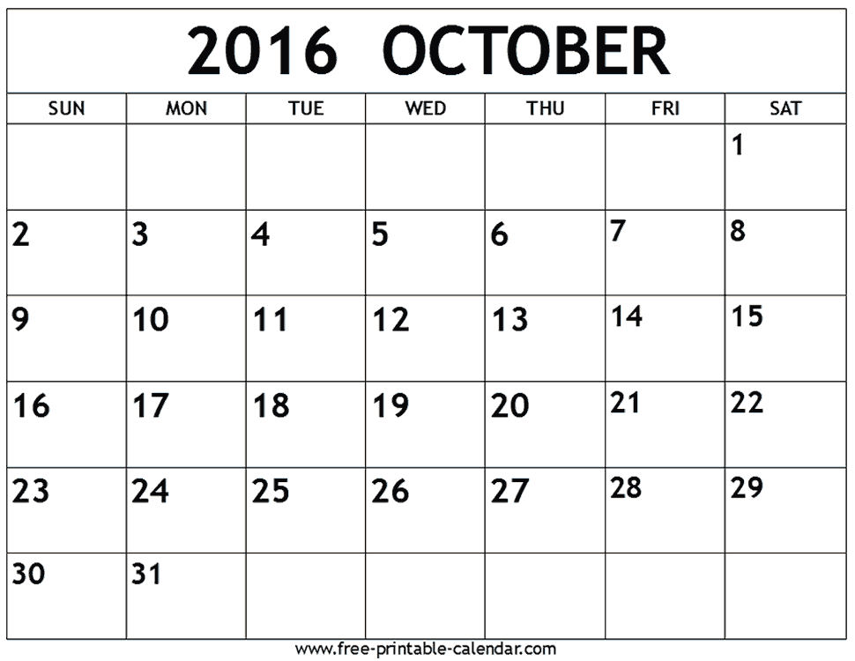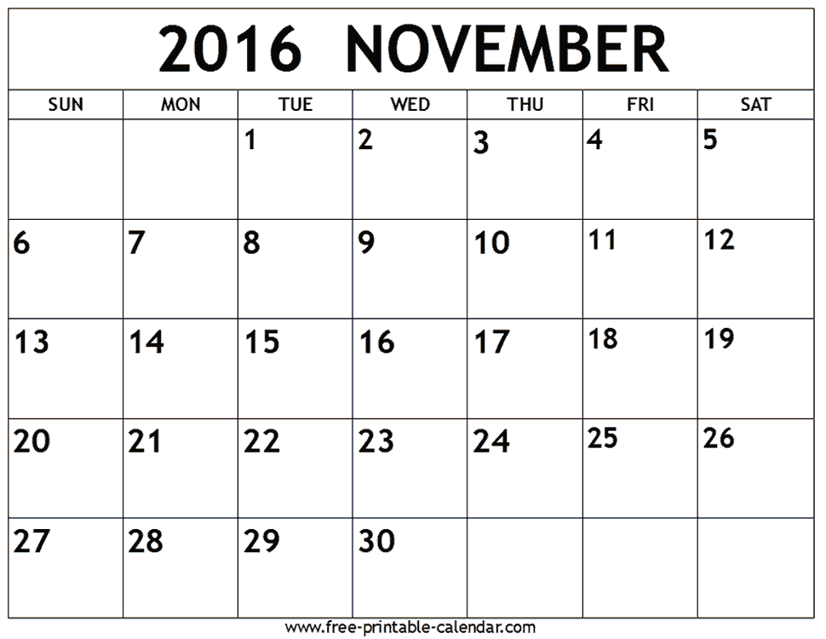
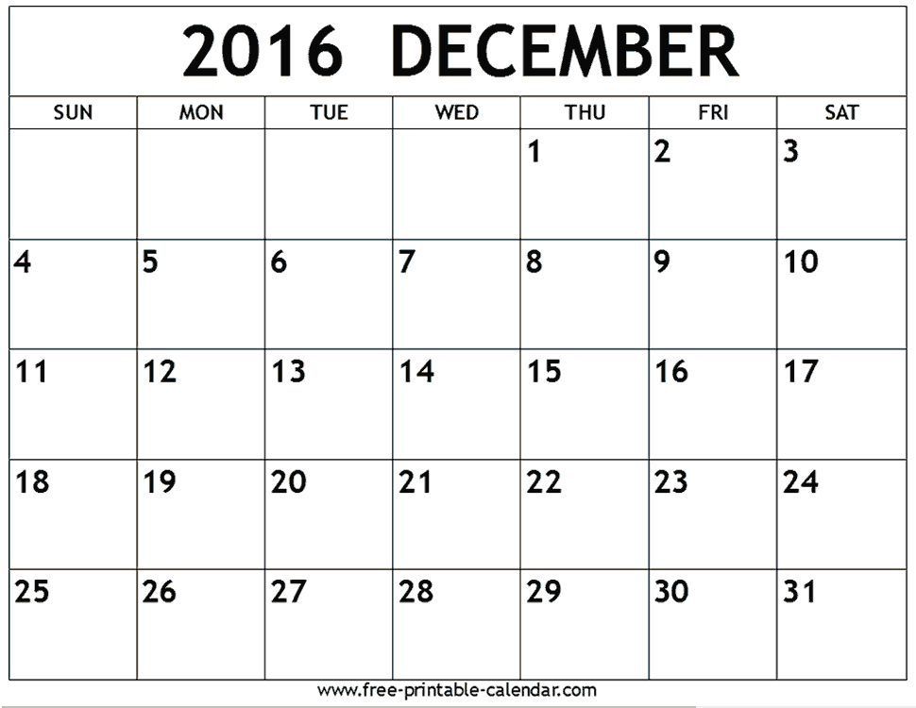

Points Break Down

Assignment | Total Possible Points | Due Date
Discussion Board (7) | 224 (32/forum) | See Course Schedule
Online Preparedness Paper | 20 | Week 1
Self-Care Reflection and Wellness Plan | 75 | Week 2
Agency Interview and Review | 100 | Week 4
Quizzes | 125 | Weekly
Program Proposal with Literature Review | 150 | Week 8
Collegial Review of 3 Proposals | 30 | Week 8
TOTAL | 724

Grading Scale

Percent | Points | Grade
90 and above | 648 – 724 pts | A
80 - 89 | 576 - 647 pts | B
70 - 79 | 503 – 575 pts | C
69 and below | 0-502 points | F

Course Schedule**: (**Course is subject to adjustment by instructor.)

 | Topics | Assignments
Week 1 | What is Mental Health Counseling?  Historical Prospective  Theoretical Foundations  Facts About Clinical Mental Health Counselors  Self-Care | Read Chapters (Chps.) 1, 2, 3 & 4 (Gerig)  Go to http://amhca.site-ym.com/?page=faq#CMHC  and read What is a clinical mental health counselor?  Read article on Self-Care: http://tpcjournal.nbcc.org/wp-content/uploads/thompson-triceblack-frick-Article.pdf  Assignment: Introduction Discussion Posting, Due Wednesday by 11:59PM  Assignment: Discussion Questions (DQ) #1, Main Posts due by Friday by 11:59 PM and Follow-up Responses to Colleagues due by Wednesday by 11:59 PM (This is only for this week due to Fall Break.)  Assignment: Online Preparedness Paper Friday by 11:59PM  Quiz
Week 2 | Credentialing of Mental Health Counselors  Ethical and Legal Issues  Mental Health Counselor Settings of Employment  Appraisal and Research | Read Ch. 5, 6, 7 & 8 (Gerig)  Assignment: Self-Care Reflection Paper Due Monday by 11:59PM  Assignment: DQ #2, Main Posts due by Friday by 11:59 PM and Follow-up Responses to Colleagues due by Monday by 11:59 PM  Quiz
Week 3 | Diversity and Mental Health Counseling  Moving from Stigma to Recovery | Read Part 4 (Chs. 9 and 12) (Rosenburg)  Read Part 1 (Chs. 1, 2, & 3) (Rosenburg)  Assignment: DQ #3, Main Posts due by Friday by 11:59 PM and Follow-up Responses to Colleagues due by Monday by 11:59 PM  Quiz
Week 4 | Mental Health Across the Life Cycle  Managed Care and Third Party  Reimbursements | Read Part 3 (Chs. 6, 7, & 8) (Rosenburg)  Read Ch. 10 (Gerig)  Assignment: Agency Review Paper, Due Monday by 11:59PM  Quiz  Watch the Free AMHCA Webinar:  Medicare & Obamacare Challenges for the Profession (http://instantteleseminar.com/?eventID=46844310)  - Learn about the challenges that Accountable Care Organizations pose to the profession as reform reshapes practice opportunities  - Position yourself to form your strategies for advocacy action and placement of your practice in your local market  Read Article: Medicare and Professional Counselors  http://www.nbcc.org/Advocacy/MedicareAndProfessionalCounselors  (http://www.amhca.org/member/affect.aspx)  Assignment: DQ #4, Main Posts due by Friday by 11:59 PM and Follow-up Responses to Colleagues due by Monday by 11:59 PM
Week 5 | Policy and Practice  Best Practices in Mental Health Counseling | Read Part 6 (Chs. 17 & 18) (Rosenburg)  Read Part 5 (Chs. 13 & 16) (Rosenburg)  Assignment: DQ #5, Main Posts due by Friday by 11:59 PM and Follow-up Responses to Colleagues due by Monday by 11:59 PM  Quiz
Week 6 | Emerging Trends in Mental Health Counseling | Read Part 2 (Chps. 4 & 5) (Rosenburg)  Chps. 11 & 12 (Gerig)  Assignment: DQ #6, Main Posts due by Friday by 11:59 PM and Follow-up Responses to Colleagues due by Monday by 11:59 PM  Quiz
Week 7 | ACA Applauds Secretary Clinton’s Proposed Mental Health Plan  https://www.counseling.org/news/updates/2016/08/31/aca-applauds-secretary-clinton-s-proposed-mental-health-plan | Tuesday, 22nd and Monday, 28th (11:59PM) only week.  Assignment: DQ #7, Posts due by Monday by 11:59 PM  Have a Happy Thanksgiving Holiday! (Wednesday, 23rd – Sunday, 27th)
Week 8 | Review of Clinical Mental Health Counseling | Assignment: Program Proposal with Literature Review Due Wednesday, November 30th  Assignment: Peer Review of 3 Proposals Due Monday, December 5th  Assignment: DQ #8, Main Posts due by Tuesday the 6th by 11:59 PM

Contents of this syllabus are subject to change due to the dynamic characteristics of the learning environment.

***Students with documented disabilities needing special assistance, please contact Student Support Services at (919)530-6325.***

Grammar and formatting: In addition to grading your content, your grammar and format and level at which you address the NCATE and CACREP standards will also account for your grade. Please adhere to the following:
- APA STYLE: Each student is required to turn in all assignments using the latest APA style. No exceptions will be made. This is an advanced level course and points will be deducted for not following APA style.
- TITLE: You must have a title page: In addition to the required components in the APA manual you are to include the course [CON 5360: Multicultural and Gender Issues in Counseling (Summer 2011) and the date you submitted the paper.] You also should have an appropriate Running head as well. Please see http://www.youtube.com/watch?v=5W2cfrJ6FCY for instructions on how to incorporate a Running head.
- HEADERS: You must utilize headers in all your paper. Headers help to organize your paper and thoughts. Please page 62-62 in the APA 6th edition manual for a written explanation as well as pages 41-51 for visual examples.
- IN-TEXT REFERENCES: Several of your assignments require that you have references. Each paragraph should have at least one in-text citation to support the points you make in each paragraph. Parenthetical notation looks like this: (Author’s Last, Name, Year). You may cite more references as you need to support your points. Please see pages 174-179 in the APA 6th edition manual for further details. Should you use a direct quote you must include the location (page number or paragraph number for websites with no page numbers). Note the rules for quotes under 40 words and 40 or more words.
- PARAPHRASE: “To paraphrase means to express someone else’s ideas or research in your own words. The paraphrase must be entirely in your own words. You must do more than merely substitute phrases here and there.” (University of Toronto, 2002, p. 1). You must also completely alter the sentence structure. Be sure you use citations for all paraphrased and quoted material. (See for http://www.utoronto.ca/ucwriting/pdf/paraphrase.pdf for more on how to paraphrase.)
- PLAGIARISM: “Research-based writing in American institutions, both educational and corporate, is filled with rules that writers, particularly beginners, aren't aware of or don't know how to follow. Many of these rules have to do with research and proper citation. Gaining a familiarity of these rules, however, is critically important, as inadvertent mistakes can lead to charges of plagiarism, which is the uncredited use (both intentional and unintentional) of somebody else's words or ideas.
“While some cultures may not insist so heavily on documenting sources of words, ideas, images, sounds, etc., American culture does. A charge of plagiarism can have severe consequences, including expulsion from a university or loss of a job, not to mention a writer's loss of credibility and professional standing” (Stolley & Brizee, 2011). (Please see http://owl.english.purdue.edu/owl/resource/589/01/)
Also please read the types of plagiarism (e.g. self-stealer) on http://www.plagiarism.org/plag_article_types_of_plagiarism.html so that you understand the breath of what plagiarism is and what it is not.
- REFERENCE PAGE: The references should match the sources listed in the in-text citations. There should not be any references that were not listed in the body of the document as well as none missing that were used in the body of the document. One way to ensure that the in-text citations are in the reference page is to add the references to the reference page as you cite in the text. Remember, the word “Reference” should be on the first line of page used for the reference. It should be centered and bold as well. Please see pages 180-224 in the APA 6th edition manual for extensive details on how to make a reference page.
- COMMON GRAMMATICAL & TYPOGRAPHICAL ERRORS:
(a) Periods and commas always go inside quotation marks, even inside single quotes. For Example: The sign changed from "Walk," to "Don't Walk," to "Walk" again within 30 seconds. OR Mary said, "He said, 'We’ll have pizza.'" For more information: http://www.grammarbook.com/punctuation/quotes.asp ;
(b) Be careful about your Subject Verb agreement. Remember singular subjects need singular verbs; plural subjects need plural verbs. For example, this is sentence is incorrect: “They was arguing so much that it was affecting their children.” This is the corrected sentence: “They were arguing so much that it was affecting their children.” Here is a link for more information on this topic: http://grammar.ccc.commnet.edu/grammar/sv_agr.htm ;
(c) Please avoid contractions. Rather than “don’t” use “do not”;
(d) Spell out abbreviations when first used. For example "The American Counseling Association (ACA) includes a number of specialty divisions." After you spell out the abbreviation you can then use the abbreviation throughout the text. For example “I am a member of ACA.”;
(e) In order to reduce bias in language the APA manual states that “Racial and Ethnic groups are designates by proper nouns and are capitalized. Therefore, use Black and White instead of black and white (colors to refer to other human groups are considered pejorative and should not be used; Publication Manual of the American Psychological Association, 2009, p. 75)”; and
(f) Remember that the word "your" indicates possession, as in your counselor. “You're” is a contraction for “you are.”

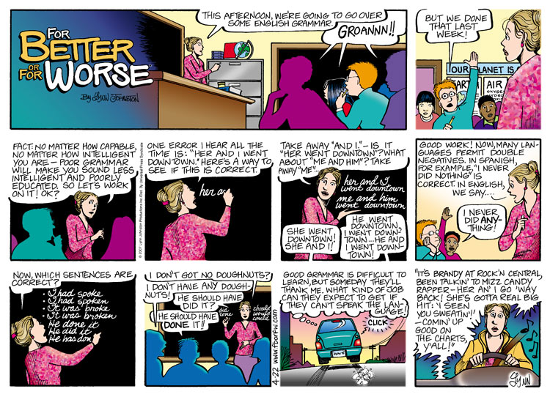
Course Resources

Bem, S. L. (1993). The lenses of gender: Transforming the debate on sexual inequality. New Haven, CT: Yale University Press.
Clark, R., Anderson, N., Clark, V., & Williams, D. (1999) Racism as stressor for African Americans. American Psychologists, 54, 805-816.
Cohen, S. Kessler, R.C., & Gordon, L.U. (Eds.). (1995). Measuring Stress: A Guide for Health and Social Scientists. Oxford, UK: University Press.
Cromier.S., Nurius,P., & Osborne, C.(2013). Interviewing and change strategies for helpers: Fundamental skills and cognitive behavioral interventions. (7th ed.). Belmont, CA:Brooks/Cole.
Dass-Brailsford, P. (2007). A practical approach to trauma: Empowering interventions. Thousand Oaks, CA: Sage Publications
Dohrenwend B. S. (1978). Stress and community psychology. American Journal of Community Psychology, 6, 1-14.
Eagly, A.H. (1996). Gender and altruism. In J.C. Chrilser, C. Golden, & P.D. Rozee (Eds), Lectures on the Psychology of Women (pp.43-60) New York: McGraw Hill.
Folkman, S., & Lazarus, R., (1988). Manual for the ways of coping questionnaire. Palo Alto, CA: Consulting Psychologist Press.
Gehart.D., (2013). Theory and Treatment Planning in Counseling and Psychotherapy. Belmont, CA: Brooks/Cole
Gladding, S. & Newsome, D. (2014). Clinical mental health counseling in community and agency settings. (4th ed.). Upper Saddle River, NJ: Pearsons.
Guthrie, R.V. (2003). Even the rat was white: A historical view of psychology. (2nd ed.).Needham Heights, MA: Allyn & Bacon.
Hall, L.K. (2008). Counseling military families: What counselors need to know. New York, NY: Taylor and Francis.
Hershenson, D.B., Power, P.W., & Waldo, M. (1996). Community counseling: Contemporary theory and practice. Boston: Allyn & Bacon.
Hirschfeld, M. & Cody, J. (2004). Collaborative healing: A “shorter” therapy approach for survivors of sexual abuse. Eau Claire, WI: Pesi Healthcare, LLC
Krohne, H.W. (1996). Individual difference in coping. In M. Zeider, & N. Endler (Eds.) Handbook coping. (pp. 381-409). New York, NY: John Wiley and Sons.
McClam, T. & Woodside, M. (2007). Generalist case management: A method of human service delivery (3rd. ed).
Myers, L. J., Speight, S. L., Highlen, P. S., Cox, C. I., Reynolds, A. L., Adams, E. M., and Hanley, T. C. (1991). Identity development and worldview: An optimal conceptualization, Journal of Counseling and Development, 70, 54-63.
Parham, T (1989). Cycles of psychological nigrescence. The Counseling Psychologist17(2) 187-226).
Parham, T. &White, J. (2010). The psychology of Blacks: An African centered perspective. (4th ed.).Upper Saddle River, NJ: Prentice Hall.
Levounis, Petros, Drescher, Jack & Barber,Mary (Eds.). (2012). The LGBT casebook. Arlington, VA: American Psychiatric Association.
Scurfield, M.R. (2001). Positive and negative aspects of the exposure to racism and trauma: Research assessment and treatment implications. National Center for Posttraumatic Stress Disorder Clinical Quarterly, 10, 1-10.
Teed, E. & Scileppi, J. (2007). The community mental health system: A navigational guide for providers. Boston, MA: Pearson Education, Inc.
Wood-Robinson, (2012). The convergence of race, ethnicity
and gender: Multiple Identities in counseling. (4th ed.). Upper Saddle River, NJ: Prentice-Hall.

