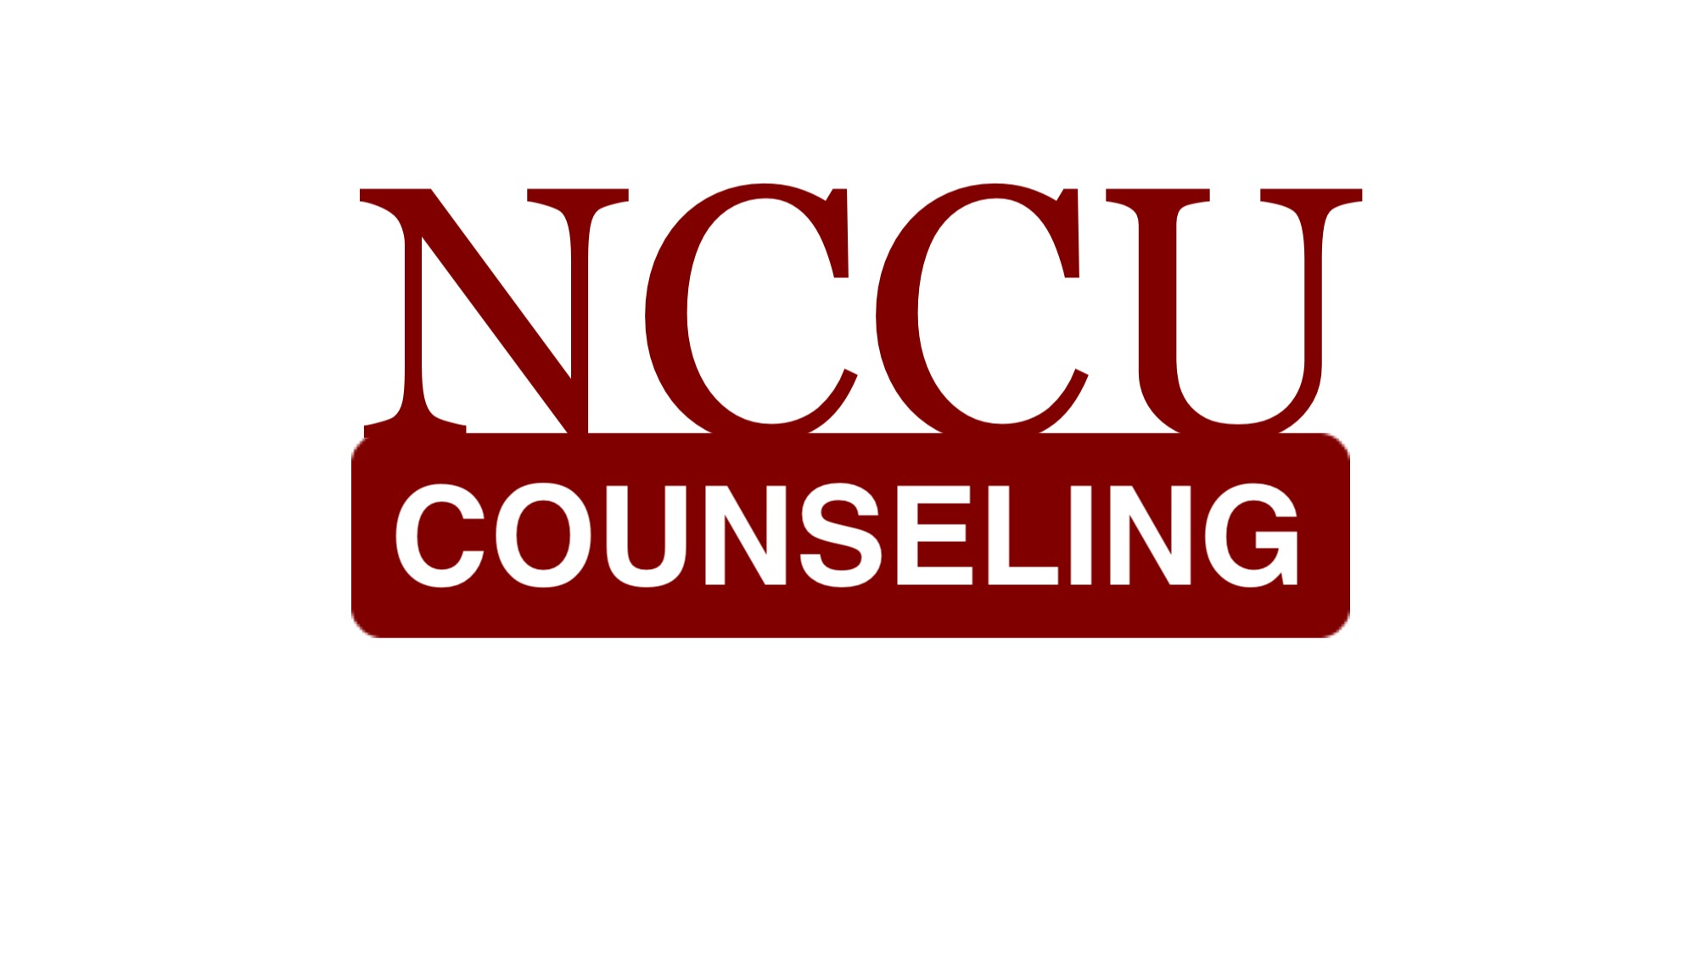
North Carolina Central University
“Communicating to Succeed”
“Preparing Educators for Diverse Cultural Contexts for the 21st Century”

The School of Education’s Vision: To become an international community of scholars who are culturally responsive educators and practitioners
COUNSELOR EDUCATION PROGRAM MISSION

The mission of North Carolina Central University is to prepare students academically and professionally to become leaders to advance consciousness of social responsibility in a diverse, global society. In accordance with the larger institution, the mission of the North Carolina Central School of Education is “to prepare educational professionals to serve and inspire excellence in teaching, administration, counseling, communication, technology, community outreach, and other related services”. Central to this aim is “the development of leaders who promote social justice and dedicate themselves to the well-being of a global society”. The Counselor Education Program prepares counselors to work in mental health, school, and career counseling settings who promote social justice and responsibility, serve as leaders in a diverse and global community, and respond to the complexity of human needs across the lifespan. To this end, the program emphasizes increasing awareness, knowledge, and skills in interacting with economically, socially, and culturally diverse populations. Our partnerships with local agencies and schools foster an understanding of multicultural and diverse populations and counseling interventions that promote empowerment.

www.nccucounseling.com

Syllabus

CON 5361
Assessment, Evaluation, & Analysis in Counseling

Spring 2019

Instructor: Kyla M. Kurian, Ph.D., LPC
Campus Office: 2122 School of Education
Telephone: 919/530-6692
Skype username: chadwick.royal
email: kkurian@nccu.edu
Office Hours (campus): Tues. 11am-3pm, Thurs. 10 AM – 1 PM
Office Hours (virtual): Mon. 10am-1pm

Required texts

Hays, D. (2017). Assessment in Counseling: A guide to the use of psychological assessment procedures (6th edition). Alexandria, VA: American Counseling Association.
American Psychiatric Association. (2013). Diagnostic and statistical manual of mental disorders (5th edition). Washington, DC: Author.
Corcoran, K., & Fischer, J. (2013). Measures for clinical practice and research – a sourcebook: Volume 1 – Couples, Famillies, and Children (5th edition). New York: Oxford University Press.
Corcoran, K., & Fischer, J. (2013). Measures for clinical practice and research – a sourcebook: Volume 2 – Adults (5th edition). New York: Oxford University Press.
You may find older editions of the Corcoran and Fischer texts online at a very reasonable price.

COURSE DESCRIPTION:

This class provides an examination of the clinical skills used in client assessment and diagnosis with an overview of the Diagnostic and Statistical Manual of Mental Disorders. Experience in selecting, administering, scoring and interpreting tests and other assessment tools commonly used by counselors will be provided.

Course Prerequisites:

A minimum of 15 hours of courses in counseling (all phase 1 counseling courses).

COURSE WEBSITE: https://nccu.blackboard.com/

You will be required to log on to the blackboard system in order to complete assignments during the semester (e.g., submit assignments, obtain handouts).

Foliotek Statement:

Maintaining an electronic portfolio (i.e., 'Foliotek') is a REQUIREMENT for continued enrollment as a degree-seeking student in the School of Education at North Carolina Central University. You MUST maintain a Foliotek account while enrolled in school, and you will be required to upload a majority of your assignments to the system. The university will use the information to track data and verify that you have met competencies of your program of study - but more importantly - this system will serve as your own professional e-portfolio and file storage. There will be multiple assigments from this class that you will need to upload to Foliotek once the course ends. Some of the assignment names may be different than what appears in Foliotek.

COUNSELOR EDUCATION PROGRAM OBJECTIVES

The program develops counselors who:
- Develop a theoretically solid philosophy of practice;
- Apply knowledge, skills, and dispositions consistent with the ACA Code of Ethics;
- Formulate a professional identity that responds to the needs of their client populations;
- Utilize cultural competence in practice;
- Act with expertise in individual, group, and family counseling with diverse clients on personal, social, emotional, career, and educational issues that impact development across their lifespan;
- Develop leadership ability and advocate to meet client needs and to remove individual and systemic barriers to development;
- Build and sustain collaborative partnerships with stakeholders for promoting social justice, equity, and access;
- Utilize appropriate assessment tools and procedures;
- Consult with others concerning the developmental needs of culturally diverse clients;
- Integrate research data into evidence-based practice.

CACREP STANDARDS ADDRESSED IN THIS COURSE

- Historical perspectives concerning the nature and meaning of assessment (Section 2.F.7.a).
- methods of effectively preparing for and conducting initial assessment meetings (Section 2.F.7.b).
- procedures for assessing risk of aggression or danger to others, self-inflicted harm, or suicide (Section 2.F.7.c).
- procedures for identifying trauma and abuse and for reporting abuse (Section 2.F.7.d).
- use of assessments for diagnostic and intervention planning purposes (Section 2.F.7.e).
- basic concepts of standardized and non-standardized testing, norm-referenced and criterion-referenced assessments, and group and individual assessments (Section 2.F.7.f).
- statistical concepts, including scales of measurement, measures of central tendency, indices of variability, shapes and types of distributions, and correlations (Section 2.F.7.g).
- reliability and validity in the use of assessments (Section 2.F.7.h).
- use of assessments relevant to academic/educational, career, personal, and social development (Section 2.F.7.i).
- use of environmental assessments and systematic behavioral observations (Section 2.F.7.j).
- use of symptom checklists, and personality and psychological testing (Section 2.F.7.k).
- use of assessment results to diagnose developmental, behavioral, and mental disorders (Section 2.F.7.l).
- ethical and culturally relevant strategies for selecting, administering, and interpreting assessment and test results (Section 2.F.7.m).

CON 5361 - STUDENT LEARNING OUTCOMES

Students will be able to . . .
- Explain intelligence, aptitude, achievement, interest, and personality assessment
- Explain selection criteria for various types of assessment methods
- Apply validity considerations to specific assessment methods and situations
- Apply reliability considerations to specific assessment methods and situations
- Select assessment methods appropriate in practical situations
- Apply and interpret psychometric statistics in practical situations
- Assist school staff with interpretation of test results to examine instructional objectives and to do curriculum planning

COURSE FORMAT

This course will be presented as a Face to Face course with online enhancements. We will have face to face meetings each week and you will be expected to check the BlackBoard Shell for online componenets.

COURSE POLICIES AND EXPECTATIONS

- All work submitted should reflect graduate level content and preparation. Careless preparation (i.e., spelling and grammatical errors) or inappropriate presentations will negatively affect the grade for that assignment or task. Do not submit any work that you have not proofread. Late assignments, if accepted, will have a reduced grade.
- Please complete all of your coursework independently, unless the assignment specifically requires collaboration with classmates. All of your coursework should be attempted on your own. Plagiarizing work in any assignment will result in automatic failure in the course.
- Read the entire syllabus. Follow all directions and due dates provided in the syllabus and on the website (no exceptions).
- Read and listen/watch all material provided on the course website as it is presented (e.g., PowerPoint Presentations, videos, podcasts, supplemental readings, etc.). Complete all assigned readings. It is not acceptable to read only a portion of the reading assignments for this course. You are expected to be prepared to discuss, summarize, and react to all readings.
- Regularly check your NCCU email account. I will correspond with you from time to time via campus email. If you are not receiving communication because you aren’t checking the account regularly, then it is not the fault of the instructor.
- Ensure that you are entirely familiar with all functions available to you via Blackboard. Not knowing how to use various functions of Blackboard is not an excuse for not completing assignments. Contact the campus ITS helpline should you experience technical problems related to Blackboard (919/530-7676).
- Do not email your work to the instructor unless specifically asked to do so by the instructor. For most assignments, if not all of them, you will use designated links within Blackboard to submit your work. Please use the Blackboard system to submit your work; email submissions will not be accepted.
- You are given a "window" of time to complete assignments, and you do not have to wait until the last minute to complete your work. Please avoid doing things at the last minute. It is very unlikely that you will be given any extra time to complete an assignment if you waited until the last minute to complete a task - and then experienced an issue. Work on things early so that you can overcome the problems, should they arise.
- Adverse Weather: The University makes all decisions regarding the cancellation of classes. Because this is class has an online component (Blackboard website), there will always be work to be completed, even if the University cancels classes on campus. Please check the Bb site, should on-campus classes be cancelled – AND – please sign up for Eagle Alerts on the Emergency Webpage for NCCU.
- Extra credit opportunities are not provided in the course. What you see below are your opportunities to earn points in the course – the grade received is the grade earned.

GRADED Course assignments

Each week, you will find a numbered and dated “Unit” folder under the "Course Content" link within the course Blackboard site. You will be expected to complete all tasks within the unit folder. These tasks may include the following: quizzes, video lectures, videos, discussion boards, and readings, just to name a few. All tasks need to be completed by classtime.

1. TESTS/QUIZZES: (200 points total for all tests/quizzes)

There will be two tests (taken online; a midterm and a final). Each test is worth 50 points (total of 100). The final test is comprehensive.

There will be 10 quizzes (taken online). Each quiz is worth 10 points (total of 100).

It will be your responsibility to remember to take your tests and quizzes. Once the due date ends for a test or quiz, and the link disappears, it will not be made available again. Unfortunately, if you forget to take a test or quiz, you will be given a zero.

Each test or quiz will be automatically scored. However, I will not provide you with the correct answers until after the deadline.

All tests and quizzes will consist of multiple choice and True/False items.

2. INTAKE INTERVIEW AND MENTAL STATUS EXAM

This assignment requires a voluntary subject. Choose an individual who appears to be well adjusted and free from any psychological problems. You may not use students who are in the Counselor Education Program. Your subject must sign the necessary consent form (found at the end of the syllabus) before beginning this assignment. Ideally, you would like to select someone that you do not know very well (perhaps a friend of a friend).

Complete an intake interview and mental status exam on this individual. We will cover this material within chapter 7 of the Hays text, and review specific elements and skills within a video-lecture. There are multiple parts to be submitted for this assignment:
- You are required to audio record this interview/exam and upload the recording to its appropriate placeholder in Blackboard;
- you are also required to upload your written report* of the interview/exam; and
- you are to submit a critique of your performance (a link for this element, with specific questions to be answered, will be availalble on Blackboard).

*You will be provided with a specific report format for the intake interview assessment.

3. COUPLE ASSESSMENT AND FEEDBACK

This assignment requires two voluntary subjects (different from your first subject). Choose a couple in a relationship who appear to be well adjusted and free from any psychological problems. You may not use students who are in the Counselor Education Program. Your subjects must sign the necessary consent form (found at the end of the syllabus) before beginning this assignment. Ideally, you would like to select a couple that are not family members or close friends of yours.

Select an assessment from Volume 1 of the Corcoran and Fischer text. The assessment should focus on either (a) family functioning, (b) marital/couple relationship, or (c) sexuality. Select an assessment that you will feel comfortable administering to each partner – and discussing their results with them. You will need to pay attention to the availability of the instrument – and secure appropriate permission to use/copy the instrument (emailing/telephoning for permission).

Below are the steps and items needed to complete for this assignment:
- After gaining the couples’ consent (and consent to use an assessment), administer a paper/pencil copy of the assessment to the couple. Have them complete the assessment independent of one another (i.e., they are not to complete the assessment together) and return their answer sheets to you. Have them agree and promise not to discuss the assessment until you schedule an appointment to meet with them together.
- Review/score the instrument and draft a brief written assessment report regarding the results. Part of the report may indicate some suggestions for how to enhance their relationship. Upload a copy of the answer sheets and the report to Blakboard by the deadline indicated on the course schedule.
- Meet with the couple to present and interpret your report – and process the results. Audio record your meeting with the couple and upload your audio file to the appropriate spot on Blackboard. Larger files (such as audio) may take a while to upload. Please be patient. This is the desired method for submitting this assignment. If necessary, you may upload your recording to a secure cloud storage site (like Dropbox or Google Drive). Then, copy and paste the necessary link in the appropriate place on Bb. Make sure that you have given me permission to access the recording, but do not set the permission for just anyone to gain access to the recording. Please do not use a site like YouTube or other public file sharing site to submit this assignment.
- Submit a written critique of your performance (a link for this element, with specific questions to be answered, will be availalble on Blackboard).

4. CASE STUDY

Students will complete one case study. You will have to apply learning from the semester to the case study, providing responses to a set of open-ended questions. You must work independently on this project. Possible cases (with the questions that need to be answered) will be posted on the course Blackboard site very early in the semester.

5. ASSESSMENT FAIR

Select a topic for assessment and find one method for assessing that topic. The purpose of this assignment is to demonstrate your ability to select and critique an appropriate assessment tool for a specified topic for assessment; comprehend the pertinent professional literature; and provide a cogent, well-presented summary of the literature investigated.

Create a 5-minute video in which you discuss your topic and assessment. Students will give a brief introduction of the topic and selected tool.

The presentation video should include the following information:
- a definition and description of the topic for assessment;
- a description of one instrument that assess the topic, including identifying data (e.g., name, author, publisher, date of publication), general information (i.e., nature and purpose of the test, grade/age-group levels, scores available, methods for scoring, administration time and special features, cost), and technical features (i.e., validity, reliability, norms, adequacy of test manual and accessory materials);
- information regarding any alternative ways to assess beyond traditional assessment tools (if any); and
- a personal critique of the instrument and alternative methods.

The video should not exceed five minutes in duration. Please save your video and upload it to a video sharing site (e.g., YouTube, Vimeo). You will submit your video by copying and pasting the link to your video in the appropriate assignment area. It is recommended that you use a video/slideshow creation application to create your video (e.g., Powtoon, Adobe Spark, Animoto, etc.)

Course Schedule (Instructor reserves the right to adjust the schedule and assignments)

Notes: H = Hays text DSM = DSM-V D/O = disorder(s)

DATE | TOPIC | READINGS | ASSIGNMENT DUE  (submitted by 11:59pm)
Jan 8 | Introductions  Syllabus Review  Introduction to the DSM-V & Measures of Clinical Practice
Jan 15 | Use of Assessment in Counseling  The Assessment Process | - H: Ch. 1-2  - DSM: Attention-Deficit/Hyperactivity D/O  - DSM: Intellectual Disabilities,  - DSM: Specific Learning D/O | - Quiz
Jan 22 | Ethical, Legal, and Professional Considerations in Assessment  Multicultural Considerations in Assessment | - H: Ch. 3-4  - DSM: Communication D/O,  - DSM: Autism Spectrum D/O,  - DSM: Motor D/O, Other NeurDev | - Quiz
Jan 29 | Measurement Concepts  Understanding and Transforminig Raw Scores | - H: Ch. 5-6  - DSM: Schizophrenia Spectrum and other Psychotic D/O | - Quiz
Feb 5 | Initial Assessment in Counseling  Substance Abuse and Mental Health Assessment | - H: Ch. 7-8  - DSM: Other Conditions that May be a Focus of Clinical Attention | - Quiz
Feb 12 | Communication of Assessment Results  Sample Assessment Report | - H: Ch. 15  - H: Appendix B | - Quiz
Feb 19 | Suicide Assessments | - DSM: Depressive D/O  - DSM: Bipolar and Related D/O | - Intake Interview and Mental Status Exam assignments
Feb 26 | Mid-Term Test
Mar 5 | Assessment of Interpersonal Relationships | - H: Ch. 14  - DSM: Anxiety D/O  - DSM: Obsessive-Compulsive and Related D/O | - Quiz  - Couple Assessment Report
Mar 12 | SPRING BREAK HOLIDAY
Mar 18 | Assessment of Intelligence | - H: Ch. 9  - DSM: Trauma and Stressor-related D/O  - DSM: Dissociative D/O  - DSM: Somatic Symptoms and Related D/O | - Quiz  - Couple recording and critique
Mar 26 | Abilty Testing: Academic, Aptitude, and Achievement | - H: Ch. 10  - DSM: Feeding and Eating D/O  - DSM: Elimination D/O  - DSM: Sleep-Wake D/O  - DSM: Breathing-related Sleep D/O  - DSM: Parasomnias  - DSM: Sexual Disfunctions  - DSM: Gender Dysphoria | - Quiz
Apr 2 | Assessment of Personality | - H: Ch. 13  - DSM: Disruptive, Impulse-control, and Conduct D/O  - DSM: Paraphyilic D/O | - Quiz
Apr 9 | Substance-related and Addictive Disorders | - DSM: Subtance-related and Addictive D/O – including Non-substance-related | - Case Study
April 16 | Future Trends in Counseling Assessment | - H: Ch. 16  - DSM: Peronality D/O  - DSM: Neurocogntive D/O | - Quiz
Apr 30 | Assessment Fair Video & Final Test (Final is comprehensive)

Course Evaluation

Method | Points Available
Quizzes (10 quizzes at 10 points each) | 100
Tests (2 tests at 50 points each) – Final is comprehensive | 100
Intake Interview and Mental Status Exam | 40
Couple Assessment and Feedback | 45
Case Study | 35
Assessment Fair | 20
TOTAL | 340

Grading Scale

Point Total Final Letter Grade
306-340 A
272-305 B
238-271 C
Below 238 F

NCCU ATTENDANCE POLICY

Class attendance is expected of students at North Carolina Central University and represents a foundational component of the learning process in both traditional on-campus and online courses. Students should attend all sessions of courses for which they are registered for the entire scheduled period and are responsible for completing all class assignments. Instructors will keep attendance records in all classes. Instructors must clearly state on the syllabus how class attendance will factor into the final grade for the course. Faculty will include a written statement of the attendance guidelines in their course syllabi and will review the guidelines during the first class session. As of Fall 2017 NW and NF attendance grades will no longer be assigned.

If a student misses three consecutive class meetings, or misses more classes than the instructor deems advisable, in addition to entering the information into Grades First, the instructor will report the facts to the student’s academic dean for appropriate follow-up. Students who miss class to participate in university-authorized activities are given excused absences for the missed class time. It is the student’s responsibility to inform the instructor of such activities at least one week before the authorized absence, and to make up all work as determined by the instructor.

Statement of Inclusion/Non-Discrimination
North Carolina Central University is committed to the principles of affirmative action and non-discrimination. The University welcomes diversity in its student body, its staff, its faculty, and its administration. The University admits, hires, evaluates, promotes, and rewards on the basis of the needs and relevant performance criteria without regard to race, color, national origin, ethnicity, sex, sexual orientation, gender identity, gender expression, age, disability, genetic information, veteran's status, or religion. It actively promotes diversity and respectfulness of each individual.

Student Accessibility Services (formerly Student Disability Services)
Students with disabilities (physical, learning, psychological, chronic or temporary medical conditions, etc.) who would like to request reasonable accommodations and services under the Americans with Disabilities Act must register with the Office of Student Accessibility Services (SAS) in Suite 120 in the Student Services Building. Students who are new to SAS or who are requesting new accommodations should contact SAS at (919) 530-6325 or sas@nccu.edu to discuss the programs and services offered by SAS. Students who are already registered with SAS and who would like to maintain their accommodations must renew previously granted accommodations by visiting the SAS website at www.nccu.edu/sas and logging into Eagle Accommodate. Students are expected to renew previously granted accommodations at the beginning of each semester, preferably during the first two (2) weeks of class. Reasonable accommodations can be requested at any time throughout the semester; however, they will not be effective retroactively. Students are strongly encouraged to contact their professors to discuss the testing and academic accommodations that they anticipate needing for each class.

Students identifying as pregnant or other pregnancy-related conditions who would like to request reasonable accommodations and services under Title IX must register with SAS.

Confidentiality and Mandatory Reporting
All forms of discrimination based on sex, including sexual misconduct, sexual assault, dating violence, domestic violence, and stalking offenses, are prohibited under NCCU’s Sexual Misconduct Policy (POL 01.04.4). NCCU faculty and instructors are considered to be responsible employees and are required to report information regarding sexual misconduct to the University’s Title IX Coordinator. The Sexual Misconduct Policy can be accessed through NCCU’s Policies, Rules and Regulations website at www.nccu.edu/policies. Any individual may report a violation of the Sexual Misconduct Policy (including a third-party or anonymous report) by contacting the Title IX Coordinator at (919) 530-7944 or TitleIX@nccu.edu, or submitting the online form through the Title IX Reporting Form, located at www.nccu.edu/titleix.

Other Campus Programs, Services, Activities, and Resources
Other campus resources to support NCCU students include:
- Student Advocacy Coordinator. The Student Advocacy Coordinator is available to assist students in navigating unexpected life events (e.g. short-term illness/injury, loss of a loved one, personal crises) and guide them to the appropriate University or community resources. Students may also receive assistance with resolving some emergency financial concerns; understanding NCCU policies, rules and regulations; or general problem-solving strategies. Contact Information: Student Services Building, Room G19, (919) 530-7492, studentadvocacy@nccu.edu.
- Counseling Center. The NCCU Counseling Center is staffed by licensed psychologists and mental health professionals who provide individual and group counseling, crisis intervention, substance abuse prevention and intervention, anger management, and other services. The Counseling Center also provides confidential resources for students reporting a violation of NCCU’s Sexual Misconduct Policy. Contact Information: Student Health Building, 2nd Floor, (919) 530-7646, counseling@nccu.edu.
- University Police Department. The University Police Department ensures that students, faculty and staff have a safe and secure environment in which they can live, learn, and work. The Department provides a full range of police services, including investigating all crimes committed in and around its jurisdiction, making arrests, providing crime prevention/community programs, enforcing parking regulations and traffic laws, and maintaining crowd control for campus special events. Contact Information: 2010 Fayetteville Street, (919) 530-6106, nccupdinfo@nccu.edu.
VETERANS SERVICES
One of the goals of the faculty and the NCCU Veterans Affairs Office’s (VAO) is to provide a welcoming and supportive learning experience for veterans. Specifically, the VAO’s primary goal is to provide a smooth transition from military to college life for veterans, service members, and dependents. If you wish, please contact your professor and/or the Director of the VAO during the first weeks of class so that we may support and assist you. During your matriculation, the VAO is here to assist you with the VA Educational Benefits process and offer overall support to ensure academic progression towards graduation. For more information please contact the VAO at 919-530-5000 or veteransaffairs@nccu.edu.

Additional Resources

Aiken, L. R. (2005). Psychological Testing and Assessment (Twelfth Edition). Boston: Allyn and Bacon.
Bolles, R. N. (2015). What Color is Your Parachute 2016? A Practical Manual for Job-Hunters and Career-Changers. Berkeley, CA: Ten Speed Press.
Corcoran, K., & Fischer, J. (2013). Measures for clinical practice and research – a sourcebook: Volume 1 – Couples, Famillies, and Children (5th edition). New York: Oxford University Press.
Corcoran, K., & Fischer, J. (2013). Measures for clinical practice and research – a sourcebook: Volume 2 – Adults (5th edition). New York: Oxford University Press.
Drummond, R. J., & Jones, K. D. (2009). Assessment Procedures for Counselors (7th Ed.) New York: Pearson.
Gardner, H. (1993). Multiple intelligence’s: The theory in practice. New York: Basic Books.
Glicken, M. D. (2006). Learning from resilient people. Thousand Oaks: Sage Publications.
Kroeger, O., & Thueson, J. M. (1992). Type Talk at Work. New York: Dell Publishing.
Osborn, D., & Zunker, V. G. (2012). Using Assessment Results for Career Development (8th). Pacific Grove, CA: Brooks/Cole Publishing Company.
Othmer, E., & Othmer, S. (2001). The clinical interview using DSM-IV-TR, Volume 1. Washington, DC: American Psychiatric Association.
Parris, J. (2013). The Intelligent Clinicians Guide to the DSM-5. Oxford: Oxford University Press.
Sinacola, R. S., & Peters-Strickland, T. (2011). Basic Psychopharmacology: For counselors and psychotherapists (2nd Ed). Boston: Pearson Education.
Thorndike, R. M., & Thorndike-Christ, T. (2010). Measurement and evaluation in psychology and evaluation, 8th Ed. New York: Pearson.
Tieger, P. D., & Barron-Tieger, B. (1992). Do What You Are—Second Edition). Boston: Little, Brown, and Company.
Vaac, N. A., & Juhnke, G. A. (1997). The use of structured clinical interviews for assessment in counseling. Journal of Counseling & Development, 75, 470-480.

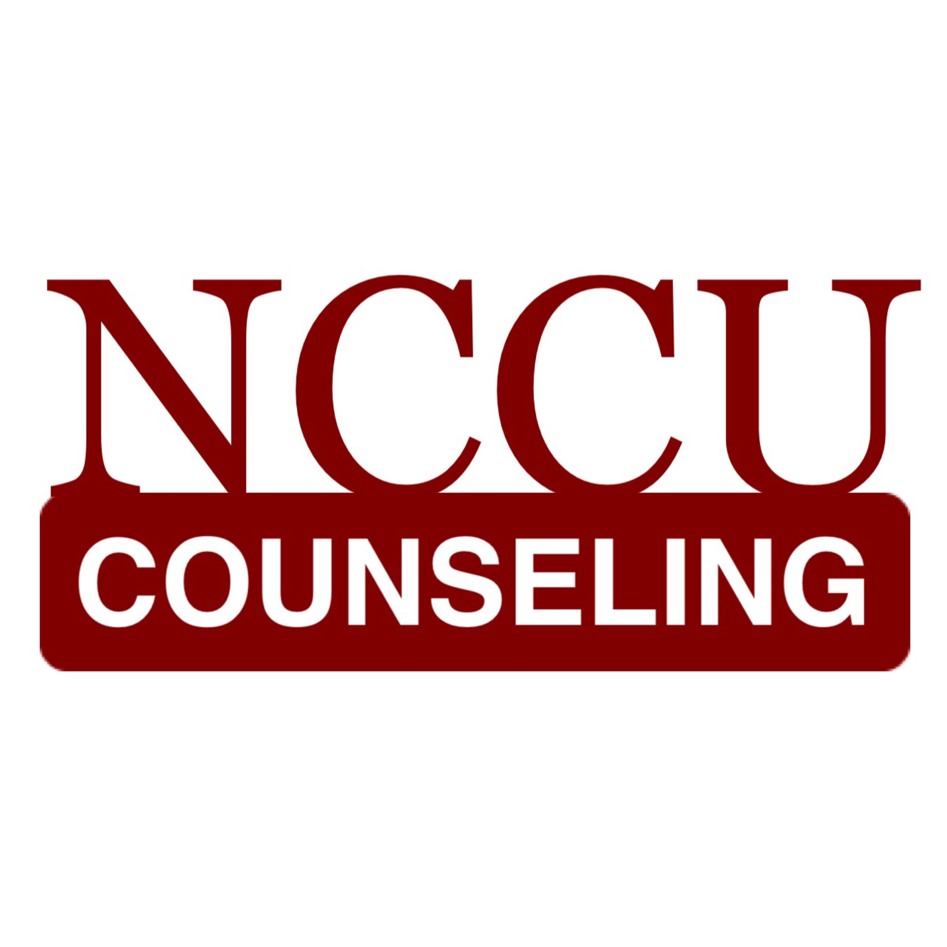

Consent to Participate and Permission for Confidential Release of Information

I, ____________________________________________________________________
(print participant’s name)

agree to participate in a project that

_____________________________________________________________________________
(print student counselor’s name)

is conducting for CON 5361: Assessment, Evaluation, and Analysis in Counseling, under the supervision of the instructor, Kyla Marie Kurian, PhD, LPC. I understand that I will be asked to respond to specific questions on an assessment or during an interview.

I will also be asked to allow the session with the student counselor to be recorded, which will take approximately 1 hour.

I understand that the recording and the results will be shared with the instructor, and that the instructor will provide feedback to the student regarding their performance. The results and the recordings will be confidential and will be deleted upon completion of the course by the student. No names will be submitted with the report.

I understand that the findings will be kept in the strictest confidence and they are intended only for the student counselor to have the opportunity to practice counseling assessment procedures to meet the requirements for his/her counselor education training program at North Carolina Central University.

I also understand that I may withdraw from this project at any time.

Signed: ________________________________________________________
(participant) (date)

Signed: ________________________________________________________
(student) (date)

